COM 414: DATA COMMUNICATION AND NETWORKS
GENERAL OBJECTIVES: On completion of this course the student should be able to:
1. Understand Data communication and different equipment’s/components used.
2. Understand the Concept of Networking Devices
3. Understand Open System Interconnect (OSI) Reference Model
4. Understand Local Area Networks and Networks of LANs.
5. Understand the Wide-Area Routing and Internetworking
6. Understand the Concept of Computer Network Topology
7. Understand the Data Link Layer
8. Understand the Physical Layer
9. Understand the basics of the Transport layer
10. Understand Network Applications and Management
11. Understand the security aspects of networks.
12. Understand the basics of Cloud computing

Introduction to Data Communications:
In Data Communications, data generally are defined as information that is stored in digital form. Data communications is the process of transferring digital information between two or more points. Information is defined as the knowledge or intelligence. Data communications can be summarized as the transmission, reception, and processing of digital information. For data communications to occur, the communicating devices must be part of a communication system made up of a combination of hardware (physical equipment) and software (programs).
The effectiveness of a data communications system depends on four fundamental characteristics: delivery, accuracy, timeliness, and jitter.
1. Delivery: The system must deliver data to the correct destination. Data must be received by the intended device or user and only by that device or user.
2. Accuracy: The system must deliver the data accurately. Data that have been altered in transmission and left uncorrected are unusable.
3. Timeliness: The system must deliver data in a timely manner. Data delivered late are useless. In the case of video and audio, timely delivery means delivering data as they are produced, in the same order that they are produced, and without significant delay.
4. Jitter: Jitter refers to the variation in the packet arrival time. It is the uneven delay in the delivery of audio or video packets.
A data communications system has five components:
Source: - This device generates the data to be transmitted; examples are mainframe computer, personal computer, workstation etc. The source equipment provides a means for humans to enter data into system.
Transmitter: - A transmitter transforms and encodes the information in such a way as to produce electromagnetic signals that can be transmitted across some sort of transmission system. For example, a modem takes a digital bit stream from an attached device such as a personal computer and transforms that bit stream into an analog signal that can be handled by the telephone network.
Transmission medium: - The transmission medium carries the encoded signals from the transmitter to the receiver. Different types of transmission media include free-space radio transmission (i.e. all forms of wireless transmission) and physical facilities such as metallic and optical fiber cables.
Receiver: - The receiver accepts the signal from the transmission medium and converts it into a form that can be handled by the destination device. For example, a modem will accept an analog signal coming from a network or transmission line and convert it into a digital bit stream.
Destination: - Takes the incoming data from the receiver and can be any kind of digital equipment like the source.
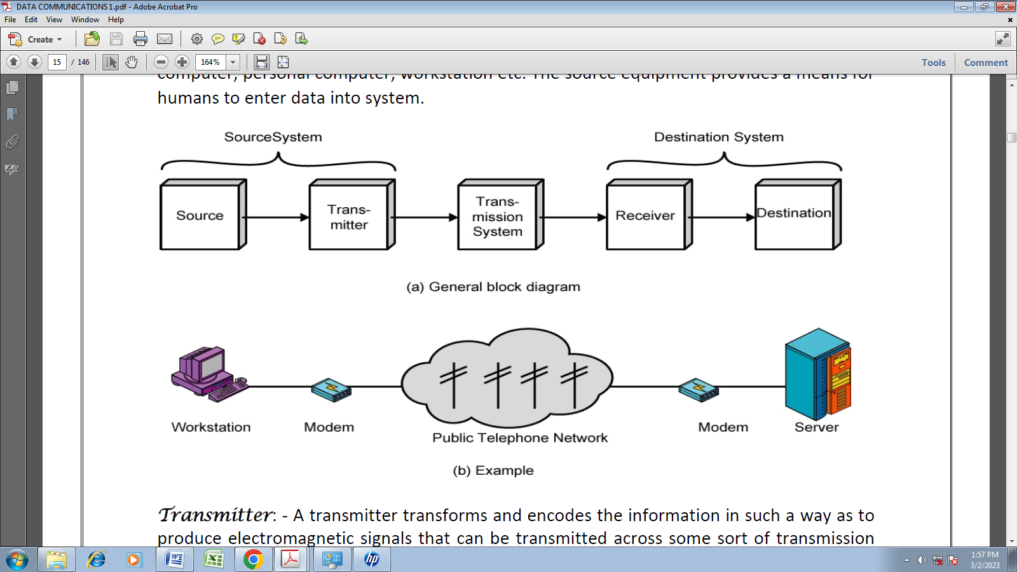
Serial and Parallel Data Transmission
There are two methods of transmitting digital data namely parallel and serial transmissions. In parallel data transmission, all bits of the binary data are transmitted simultaneously. For example, to transmit an 8-bit binary number in parallel from one unit to another, eight transmission lines are required. Each bit requires its own separate data path.
All bits of a word are transmitted at the same time. This method of transmission can move a significant amount of data in a given period of time. Its disadvantage is the large number of interconnecting cables between the two units. For large binary words, cabling becomes complex and expensive. This is particularly true if the distance between the two units is great. Long multiwire cables are not only expensive, but also require special interfacing to minimize noise and distortion problems. Serial data transmission is the process of transmitting binary words a bit at a time. Since the bits time-share the transmission medium, only one interconnecting lead is required.
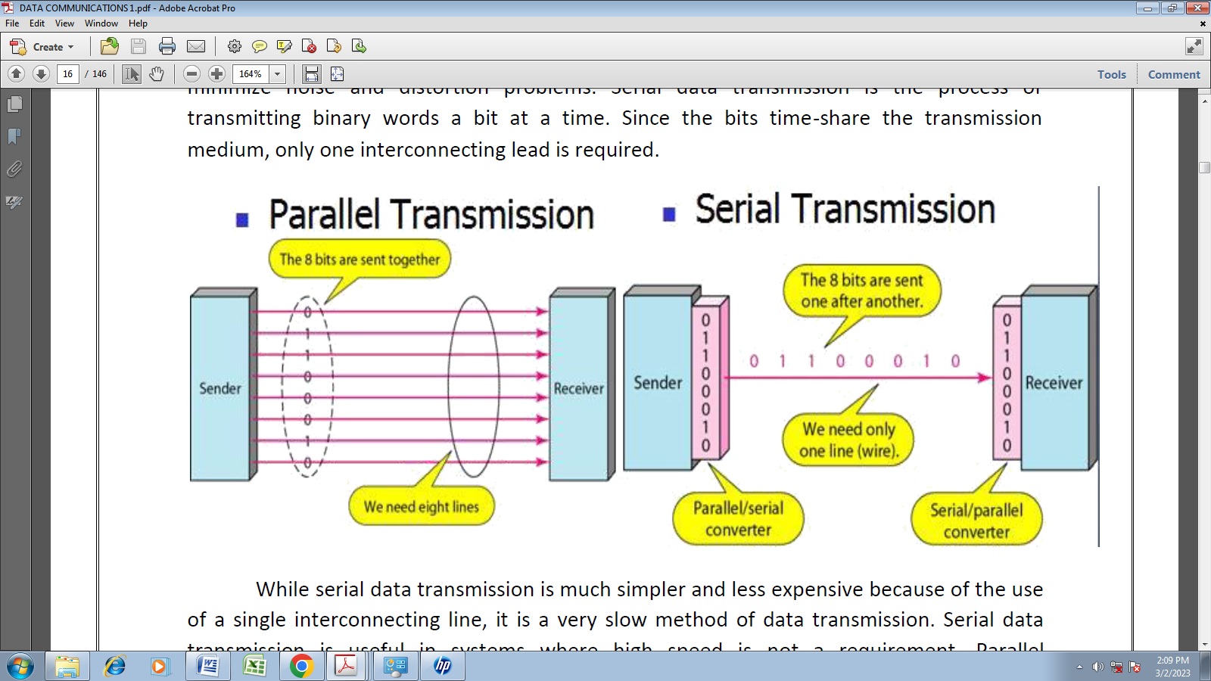
While serial data transmission is much simpler and less expensive because of the use of a single interconnecting line, it is a very slow method of data transmission. Serial data transmission is useful in systems where high speed is not a requirement. Parallel communication is used for short-distance data communications and within a computer, and serial transmission is used for long-distance data communications.
Data Communication Circuit Arrangements
A data communications circuit can be described in terms of circuit configuration and transmission mode.
Circuit Configurations / Type of Connection
Data communications networks can be generally categorized as either two point or multipoint. A two-point configuration involves only two locations or stations, whereas a multipoint configuration involves three or more stations.
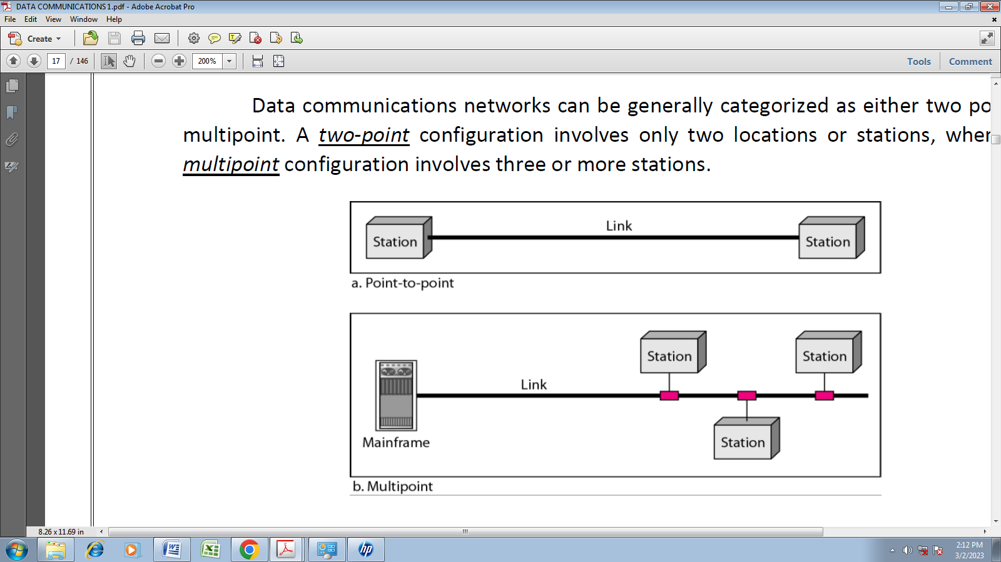
A two-point circuit involves the transfer of digital information between a mainframe computer and a personal computer, two mainframe computers or two data communications networks. A multi-point network is generally used to interconnect a single mainframe computer (host) to many personal computers or to interconnect many personal computers and capacity of the channel is either Spatially shared: Devices can use the link simultaneously or Timeshare: Users take turns
Transmission Modes
There are four modes of transmission for data communications circuits:
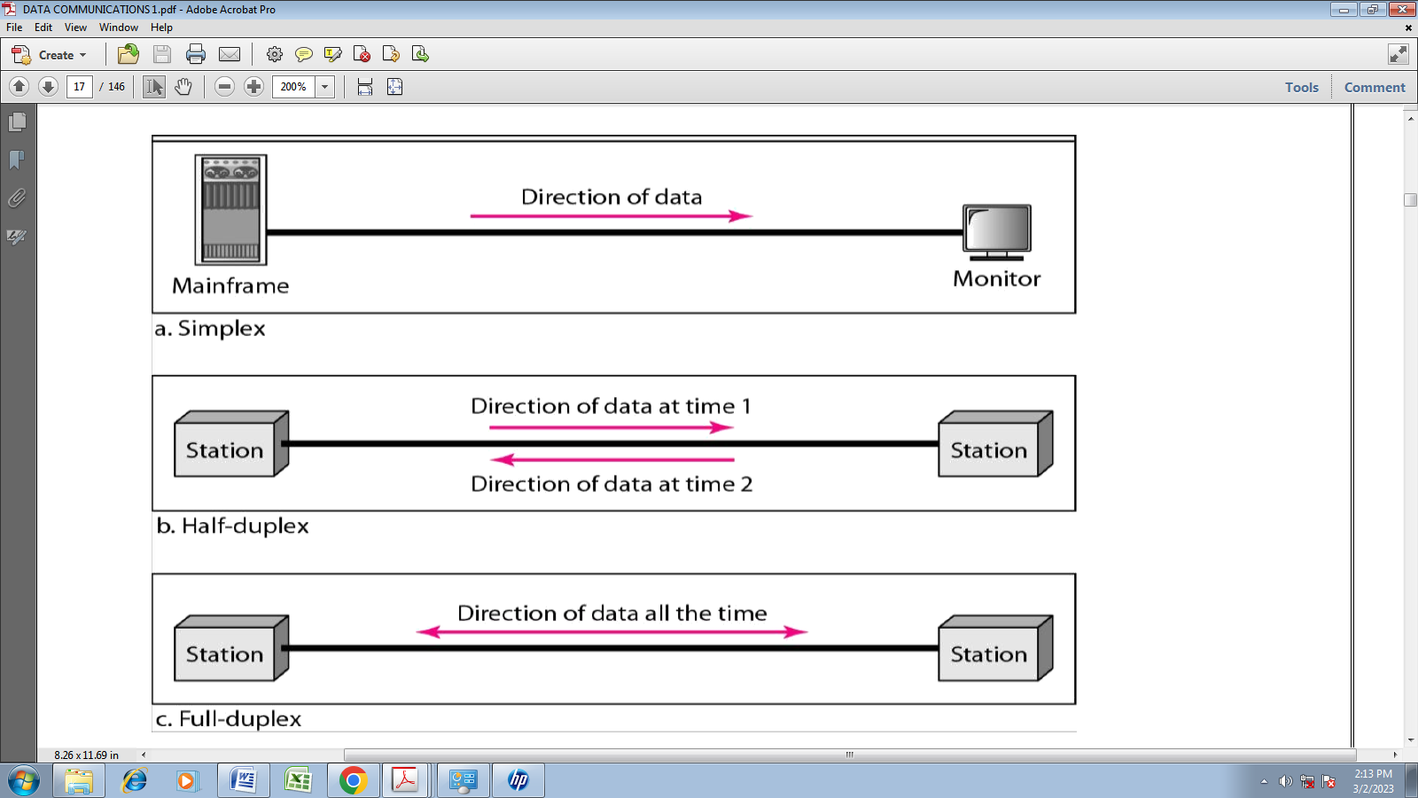
In simplex mode (SX), the communication is unidirectional, as on a one-way street. Only one of the two devices on a link can transmit; the other can only receive. Commercial radio broadcasting is an example. Simplex lines are also called receive-only, transmit-only or one-way-only lines.
In half-duplex (HDX) mode, each station can both transmit and receive, but not at the same time. When one device is sending, the other can only receive, and vice versa. The half-duplex mode is used in cases where there is no need for communication in both directions at the same time; the entire capacity of the channel can be utilized for each direction. Citizens band (CB) radio is an example where push to talk (PTT) is to be pressed or depressed while sending and transmitting.
In full-duplex mode (FDX) (called duplex), both stations can transmit and receive simultaneously. One common example of full-duplex communication is the telephone network. The full-duplex mode is used when communication in both directions is required all the time. The capacity of the channel must be divided between the two directions.
In full/full duplex (F/FDX) mode, transmission is possible in both directions at the same time but not between the same two stations (i.e. station 1 transmitting to station 2, while receiving from station 3). F/FDX is possible only on multipoint circuits. Postal system can be given as a person can be sending a letter to one address and receive a letter from another address at the same time.

Network
A network is a set of devices (often referred to as nodes) connected by communication links. A node can be a computer, printer, or any other device capable of sending and/or receiving data generated by other nodes on the network.
Network Criteria
A network must be able to meet a certain number of criteria. The most important of these are performance, reliability, and security.
Performance
Performance can be measured in many ways, including transmit time and response time. Transmit time is the amount of time required for a message to travel from one device to another. Response time is the elapsed time between an inquiry and a response.
The performance of a network depends on a number of factors, including the number of users, the type of transmission medium, the capabilities of the connected hardware, and the efficiency of the software.
Performance is often evaluated by two networking metrics: throughput and delay. We often need more throughputs and less delay.
Reliability
In addition to accuracy of delivery, network reliability is measured by the frequency of failure, the time it takes a link to recover from a failure.
Security
Network security issues include protecting data from unauthorized access, protecting data from damage and development, and implementing policies and procedures for recovery from breaches and data losses.
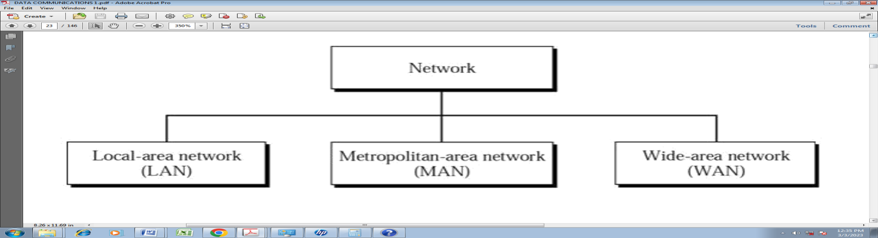
Local area network: A local area network (LAN) is a network that connects computers and devices in a limited geographical area such as home, school, computer laboratory, office building, or closely positioned group of buildings. In addition to operating in a limited space, LANs are also typically owned, controlled, and managed by a single person or organization.
 
Metropolitan area network: A MAN is optimized for a larger geographical area than a LAN, ranging from several blocks of buildings to entire cities. Its geographic scope falls between a WAN and LAN. A MAN might be a single network like the cable television network or it usually interconnects a number of local area networks (LANs) using a high capacity backbone technology, such as fiber-optical links, and provides up-link services to wide area networks and the Internet. MANs typically operate at speeds of 1.5 Mbps to 10 Mbps and range from five miles to a few hundred miles in length.
Wide area network: Wide area networks are the oldest type of data communications network that provide relatively slow-speed, long-distance transmission of data, voice and video information over relatively large and widely dispersed geographical areas, such as country or entire continent. WANs interconnect routers in different locations. A WAN differs from a LAN in several important ways. Most WANs (like the Internet) are not owned by any one organization but rather exist under collective or distributed ownership and management.
Summary
Distance Location Network Used
10 meters Classroom LAN 100 meters Building LAN 1000 meters Campus LAN
2-50 kilometers City MAN 100 kilometers County WAN 1,000 kilometers Continent WAN
10,000 kilometers Planet – Internet WAN
Campus Area Network: - a network spanning multiple LANs but smaller than a MAN, such as on a university or local business campus.
Building backbone: It is a network connection that normally carries traffic between departmental LANs within a single company. It consists of a switch or router to provide connectivity to other networks such as campus backbones, enterprise backbones, MANs, WANs etc
Camus backbone: - It is a network connection used to carry traffic to and from LANs located in various buildings on campus. It normally uses optical fiber cables for the transmission media between buildings and operates at relatively high transmission rates.
Physical Topology
The term physical topology refers to the way in which a network is laid out physically: I/O or more devices connect to a link; two or more links form a topology.
Network Topologies
In computer networking, topology refers to the layout of connected devices, i.e. how the
computers, cables, and other components within a data communications network are interconnected, both physically and logically. The physical topology describes how the network is actually laid out, and the logical topology describes how the data actually flow through the network. Two most basic topologies are point-to-point and multipoint. A point- to-point topology usually connects two mainframe computers for high-speed digital information. A multipoint topology connects three or more stations through a single transmission medium and some examples are star, bus, ring, mesh and hybrid.
Star topology: A star topology is designed with each node (file server, workstations, and peripherals) connected directly to a central network hub, switch, or concentrator. Data on a star network passes through the hub, switch, or concentrator before continuing to its destination. The hub, switch, or concentrator manages and controls all functions of the network. It also acts as a repeater for the data flow.
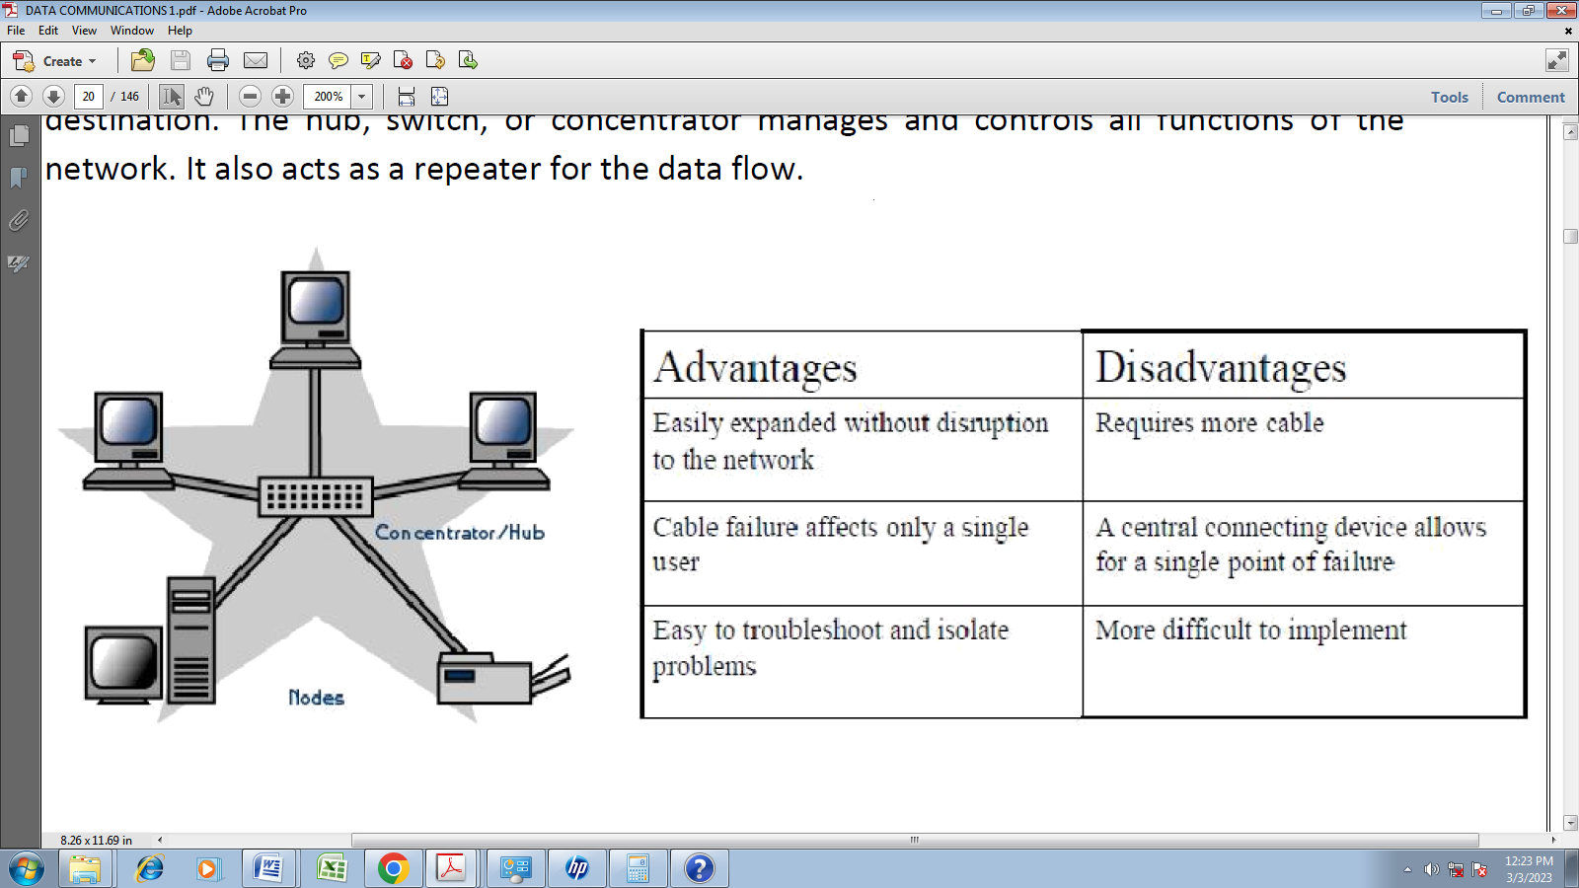 Bus topology: Bus networks use a common backbone to connect all devices. A single cable, (the backbone) functions as a shared communication medium that devices attach or tap into with an interface connector. A device wanting to communicate with another device on the network sends a broadcast message onto the wire that all other devices see, but only the intended recipient actually accepts and processes the message. The bus topology is the simplest and most common method of interconnecting computers.
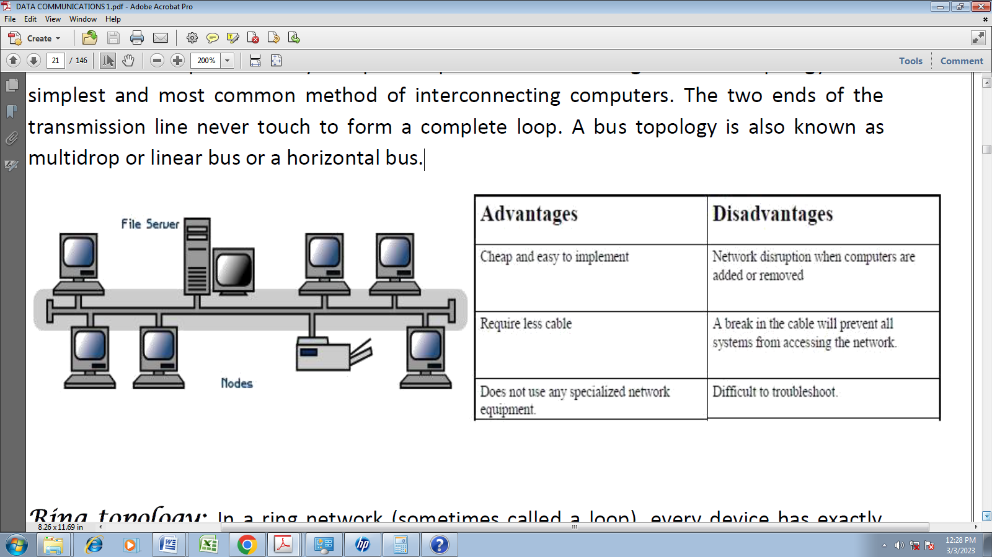
Ring topology: In a ring network (sometimes called a loop), every device has exactly two neighbors for communication purposes. All messages travel through a ring in the same direction (either "clockwise" or "counter clockwise"). All the stations are interconnected in tandem (series) to form a closed loop or circle. Transmissions are unidirectional and must propagate through all the stations in the loop. Each computer acts like a repeater and the ring topology is similar to bus or star topologies.
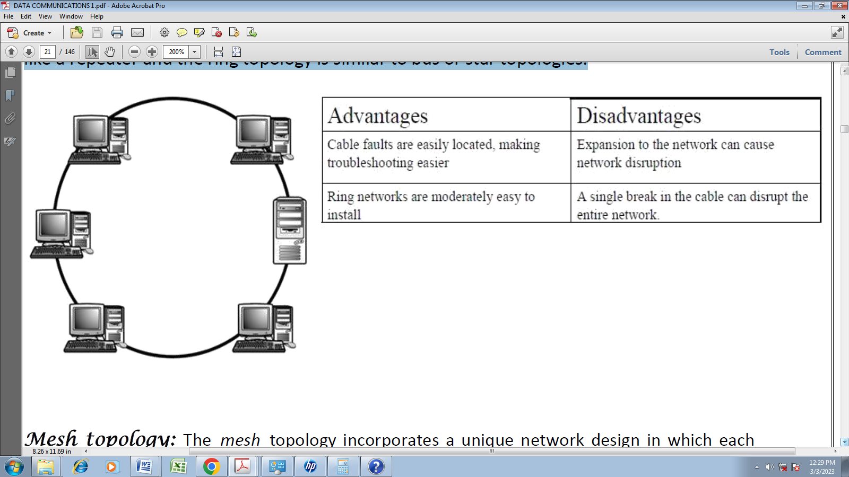
Mesh topology: The mesh topology incorporates a unique network design in which each computer on the network connects to every other, creating a point-to-point connection between every device on the network. Unlike each of the previous topologies, messages sent on a mesh network can take any of several possible paths from source to destination. A mesh network in which every device connects to every other is called a full mesh. A disadvantage is that, a mesh network with n nodes must have n(n-1)/2 links and each node must have n-1 I/O ports (links).
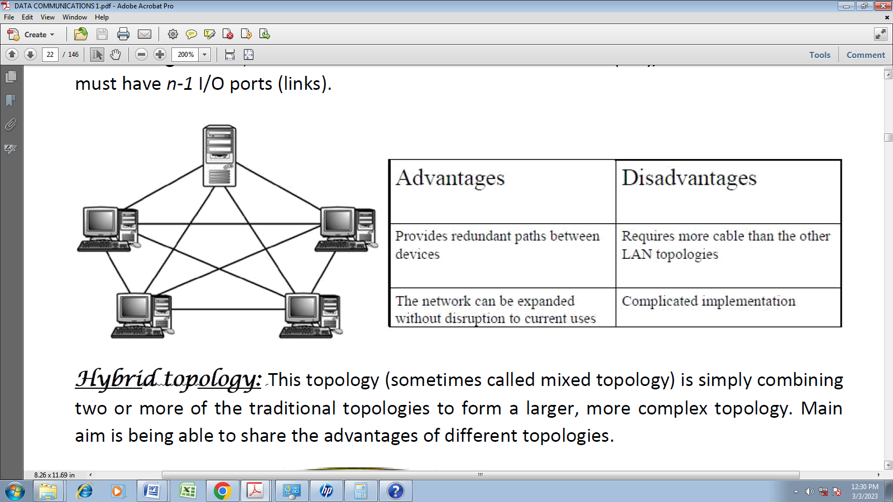
Hybrid topology: This topology (sometimes called mixed topology) is simply combining two or more of the traditional topologies to form a larger, more complex topology. Main aim is being able to share the advantages of different topologies.
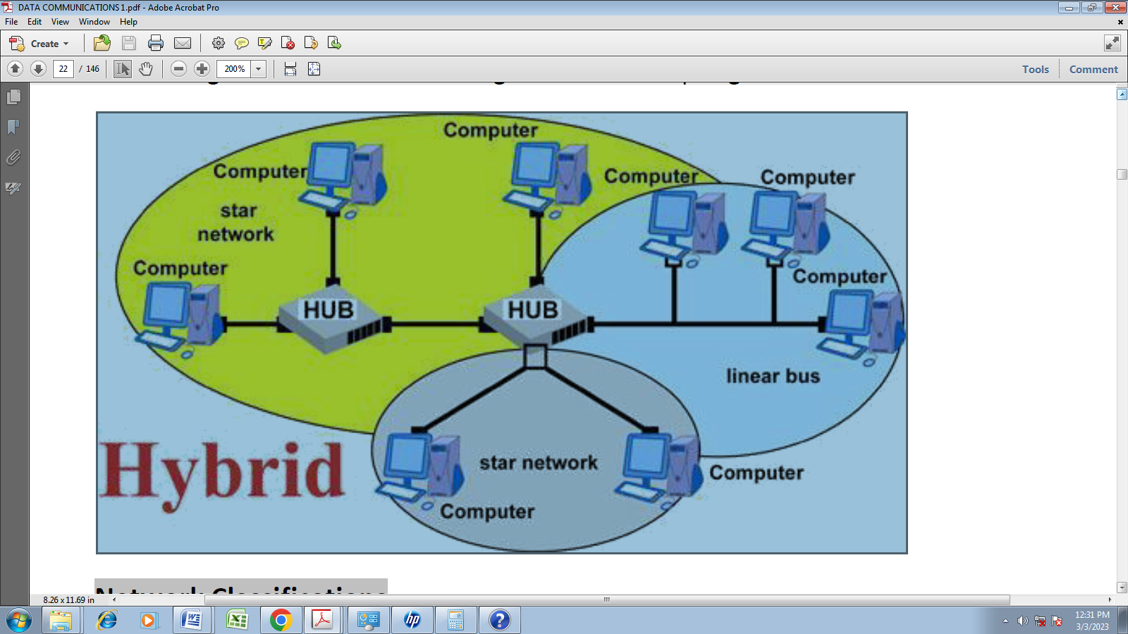
Considerations When Choosing a Topology
- Money. A linear bus network may be the least expensive way to install a network; you do not have to purchase concentrators.
- Length of cable needed. The linear bus network uses shorter lengths of cable.
- Future growth. With a star topology, expanding a network is easily done by adding another concentrator.
- Cable type. The most common cable in schools is unshielded twisted pair,
Transmission Media
The media over which the information between two computer systems is sent, called transmission media.

Transmission media can be divided into two broad categories
- Guided
All communication wires/cables are guided media, such as UTP, coaxial cables, and fiber Optics. In this media, the sender and receiver are directly connected and the information is send (guided) through it.
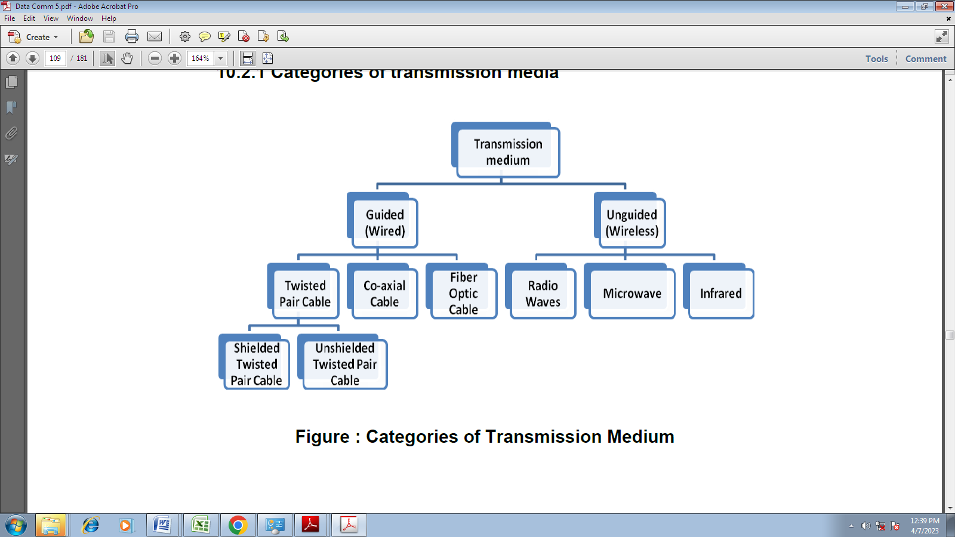
Guided media
Guided media, which are those that provide a conduit from one device to another, include twisted pair cable, coaxial cable, and fiber-optic cable.
1. Twisted-Pair Cable
A twisted pair consists of two conductors (normally copper), each with its own plastic insulation, twisted together.

One of the wires is used to carry signals to the receiver, and the other is used only as a ground reference. The most common twisted-pair cable used in communications is referred to as unshielded twisted- pair (UTP). IBM has also produced a version of twisted-pair cable for its use called shielded twisted- pair (STP). STP cable has a metal foil or braided- mesh covering that encases each pair of insulated conductors. Although metal casing improves the quality of cable by preventing the penetration of noise or crosstalk, it is bulkier and more expensive.
Applications
Twisted-pair cables are used in telephone lines to provide voice and data channels.
2. Coaxial Cable
Coaxial cable (or coax) carries signals of higher frequency ranges than those in twisted- pair cable, in part because the two media are constructed quite differently. Instead of having two wires, coax has a central core conductor of solid or stranded wire (usually copper) enclosed in an insulating sheath, which is, in turn, encased in an outer conductor of metal foil, braid, or a combination of the two. The outer metallic wrapping serves both as a shield against noise and as the second conductor completing the circuit. This outer conductor is also enclosed in an insulating sheath, and the whole cable is protected by a plastic cover.

Categories of coaxial cables

Category | Impedance | Use
RG-59 | 75Ω | Cable TV
RG-58 | 50Ω | Thin Ethernet
RG-11 | 50Ω | Thick ethernet
Applications
1. Coaxial cable is used in analog telephone network where a coaxial cable could carry 10,000 voice signals.
2. It is also used in digital telephone network where a cable could carry digital data up to 600Mbps.
3. Cable TV networks also used RG-59 coaxial cables.
4. It is also used in traditional Ethernets.
Fiber Optic Cable.
A fiber optic cable is made of glass or plastic and transmits signals in the form of light. Optical fibers use reflection to guide light through a channel.

A glass or plastic core is surrounded by a cladding of less dense glass or plastic. The difference in the density of the two materials must be such that a beam of light moving through the core is reflected off the cladding.
Propagation Modes
There are two modes for propagating light along optical channels; each requires fiber with different physical characteristics
- Multimode 2. Single mode
Multimode
Multiple beams from a light source move through the core in different paths. Multimode can be implemented in two forms
- Step-index 2. Graded index
Multimode Step –index fiber
- In Multimode Step –index fiber the density of the fiber remains constant from the center to the edges
- A beam of light moves through this constant density in a straight line.
- When it reaches the interface of the core and the cladding, there is an abrupt change to a lower density that alters the angle of the beams motion.
Multimode Graded-index fiber
- It decreases the distortion of the signal through the cable.
- Density is highest at the center of the core and decreases gradually to its lowest at the edge.
Single-Mode
- It uses step-index fiber and a highly focused source of light that limits beams to a small range of angles, all close to the horizontal
- The Single-Mode fiber itself is manufactured with a smaller diameter than that of multimode fiber and with lower density.
- This results in a critical angle that is close enough to 90 to make it horizontal.
- All the beams arrive at the destination together and can be recombined with little distortion to the signal.
Fiber Sizes
Optical fibers are defined by the ratio of the diameter of their core to the diameter of their cladding expressed in micrometers.
Application
It is used in cable TV and LAN (Fast Ethernet and 100Base –X).
Advantages
- Higher bandwidth: It can support higher bandwidth than twisted pair or coaxial cable.
- Less signal attenuation: Transmission distance is greater than that of other guided media. Signals can be transmitted for 50 km without requiring regeneration.
- Immunity to electromagnetic Interference: Electromagnetic noise can not affect fiber-optic cables
- Resistance to corrosive materials: glass is more resistant to corrosive materials.
- Light-weight: It is of less weight than the copper cables.
- More immune to taping: Fiber-optic cables are more immune to taping than copper cables.
Disadvantages:
- Installation/Maintenance. Installation/Maintenance need expertise since it is a new technology.
- Unidirectional: Propagation of light is unidirectional. Bidirectional communication is achieved by means of two optical fibers.
- Cost: It is more expensive and the use of optical fiber cannot be justified if the need for bandwidth is not high.
UNGUIDED MEDIA: WIRELESS
Wireless or open air space is said to be unguided media, because there is no connectivity between the sender and receiver. Information is spread over the air, and anyone including the actual recipient may collect the information. Unguided media transport electromagnetic waves without using a physical conductor. This type of communication is often referred to as wireless communication.
Unguided signal can travel from the source to destination in several ways:
- Ground Propagation:
a. Radio waves travel through the lowest portion of the atmosphere, hugging the earth.
b. The low frequency signal follows the curvature of the planet.
c. Distance depends on the amount of the power.
2. Sky Propagation:
a. Higher frequency radio radiate upward into the ionosphere where they are reflected back to the earth.
b. Sky propagation allow for greater distance with lower power output.
3. line-of-sight Propagation: Very high frequency signals are transmitted in straight lines directly from antenna to antenna.

Radio Waves:
- Radio Waves: Between 3 KHz – 1 GHz.
- Radio waves use omnidirectional antenna.
- Radio waves used for multicast communication, such as radio and television.
- Sky Propagation. This makes radio waves a good candidate for long-distance broadcasting such as AM radio.
Micro Waves:
1. Microwave propagation is line-of-sight. Since the towers with the mounted antennas need to be indirect sight of each other, towers that are far apart need to be very tall.
2. Very high-frequency microwaves cannot penetrate walls. This characteristic can be a disadvantage if receivers are inside buildings.
3. The microwave band is relatively wide, almost 299 GHz. Therefore wider subbandscan be assigned, and a high data rate is possible Use of certain portions of the band requires permission from authorities.
Infrared waves:
- Between 300 GHz-400 THz 2. Used for short-range communication. 3. Very common with remote control devices, but can also be used for device-to-device transfers, such as PDA to computer. 4. Line-of-sight propagation.
TRANSMISSION IMPAIRMENT
Signals travel through transmission media, which are not perfect. The imperfection causes signal impairment. This means that the signal at the beginning of the medium is not the same as the signal at the end of the medium. What is sent is not what is received. Three causes of impairment are attenuation, distortion, and noise.

Attenuation:
Attenuation means a loss of energy. When a signal, simple or composite, travels through a medium, it loses some of its energy in overcoming the resistance of the medium. That is why a wire carrying electric signals gets warm, if not hot, after a while. Some of the electrical energy in the signal is converted to heat. To compensate for this loss, amplifiers are used to amplify the signal. Loss of energy i.e. Loss in signal strength. It is measured in decibel (dB)
Decibel
To show that a signal has lost or gained strength, engineers use the unit of the decibel.
The decibel (dB) measures the relative strengths of two signals or one signal at two different points.
Note that the decibel is negative if a signal is attenuated and positive if a signal is amplified.
Distortion:
Means that the signal changes its form or shape. Distortion can occur in a composite signal made of different frequencies. In other words, signal components at the receiver have phases different from what they had at the sender.
Noise:
Noise is another cause of impairment. Several types of noise, such as thermal noise, induced noise, crosstalk, and impulse noise, may corrupt the signal. Thermal noise is the random motion of electrons in a wire which creates an extra signal not originally sent by the transmitter. Induced noise comes from sources such as motors and appliances.
Induced Noise: Produced if the source is an electrical motor or appliance.
Cross talk: Effect of one wire over another.
Impulse Noise: Is a spike produced during earth quake, thunder and lightning etc.
Data Communications Networks
Any group of computers connected together can be called a data communications network, and the process of sharing resources between computers over a data communications network is called networking. The most important considerations of a data communications network are performance, transmission rate, reliability and security.
Network Components, Functions, and Features
The major components of a network are end stations, applications and a network that will support traffic between the end stations. Computer networks all share common devices, functions, and features, including servers, clients, transmission media, shared data, shared printers and other peripherals, hardware and software resources, network interface card (NIC), local operating system (LOS) and the network operating system (NOS).
Servers: Servers are computers that hold shared files, programs and the network operating system. Servers provide access to network resources to all the users of the network and different kinds of servers are present. Examples include file servers, print servers, mail servers, communication servers etc.
Clients: Clients are computers that access and use the network and shared network resources. Client computers are basically the customers (users) of the network, as they request and receive service from the servers.
Shared Data: Shared data are data that file servers provide to clients, such as data files, printer access programs, and e-mail.
Shared Printers and other peripherals: these are hardware resources provided to the users of the network by servers. Resources provided include data files, printers, software, or any other items used by the clients on the network.
Network interface card: Every computer in the network has a special expansion card called network interface card (NIS), which prepares and sends data, receives data, and controls data flow between the computer and the network. While transmitting, NIC passes frames of data on to the physical layer and on the receiver side, the NIC processes bits received from the physical layer and processes the message based on its contents.
Local operating system: A local operating system allows personal computers to access files, print to a local printer, and have and use one or more disk and CD drives that are located on the computer. Examples are MS-DOS, PC-DOS, UNIX, Macintosh, OS/2, Windows 95, 98, XP and Linux.
Network operating system: the NOS is a program that runs on computers and servers that allows the computers to communicate over a network. The NOS provides services to clients such as log-in features, password authentication, printer access, network administration functions and data file sharing.
Network Models
Computer networks can be represented with two basic network models: peer-to-peer client/server and dedicated client/server. The client/server method specifies the way in which two computers can communicate with software over a network.
Peer-to-peer client/server network: Here, all the computers share their resources, such as hard drives, printers and so on with all the other computers on the network. Individual resources like disk drives, CD-ROM drives, and even printers are transformed into shared, collective resources that are accessible from every PC. Unlike client-server networks, where network information is stored on a centralized file server PC and made available to tens, hundreds, or thousands client PCs, the information stored across peer-to-peer networks is uniquely decentralized. Because peer-to-peer PCs have their own hard disk drives that are accessible by all computers, each PC acts as both a client (information requestor) and a server (information provider). The peer-to-peer network is an appropriate choice when there are fewer than 10 users on the network, security is not an issue and all the users are located in the same general area.
The advantages of peer-to-peer over client-server NOSs include:
- No need for a network administrator
- Network is fast/inexpensive to setup & maintain
- Each PC can make backup copies of its data to other PCs for security.
- Easiest type of network to build, peer-to-peer is perfect for both home and office use.
Dedicated client/server network: Here, one computer is designated as server and the rest of the computers are clients. Dedicated Server Architecture can improve the efficiency of client server systems by using one server for each application that exists within an organization. The designated servers store all the networks shared files and applications programs and function only as servers and are not used as a client or workstation. Client computers can access the servers and have shared files transferred to them over the transmission medium. In some client/server networks, client computers submit jobs to one of the servers and once they process the jobs, the results are sent back to the client computer.
In general, the dedicated client/server model is preferable to the peer-to-peer client/server model for general purpose data networks.
1. Understand Open System Interconnect (OSI) Reference Model
2. Understand the Data Link Layer
3. Understand the Physical Layer
4. Understand the basics of the Transport layer
Open Systems Interconnection (OSI)
International standard organization (ISO) established a committee in 1977 to develop architecture for computer communication and the OSI model is the result of this effort. In 1984, the Open Systems Interconnection (OSI) reference model was approved as an international standard for communications architecture.
The Open Systems Interconnection model (OSI) is a conceptual model that characterizes and standardizes the internal functions of a communication system by partitioning it into abstraction layers. The term “open” denotes the ability to connect any two systems which conform to the reference model and associated standards. The OSI model describes how information or data makes its way from application programmes (such as spreadsheets) through a network medium (such as wire) to another application programme located on another network.
The OSI model has seven layers. The principles that were applied to arrive at the seven layers can be briefly summarized as follows:
1. A layer should be created where a different abstraction is needed.
2. Each layer should perform a well-defined function.
3. The function of each layer should be chosen with an eye toward defining internationally standardized protocols.
4. The layer boundaries should be chosen to minimize the information flow across the interfaces.
5. The number of layers should be large enough that distinct functions need not be thrown together in the same layer out of necessity and small enough that the architecture does not become unwieldy.
The OSI reference model divides the problem of moving information between computers over a network medium into SEVEN smaller and more manageable problems. The seven layers are:
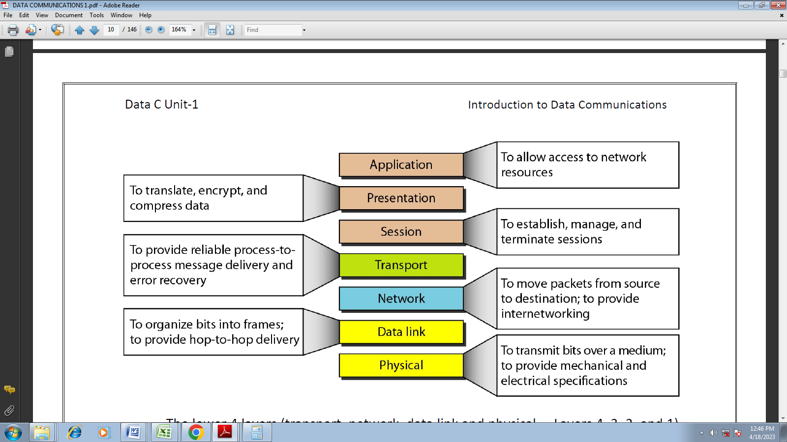
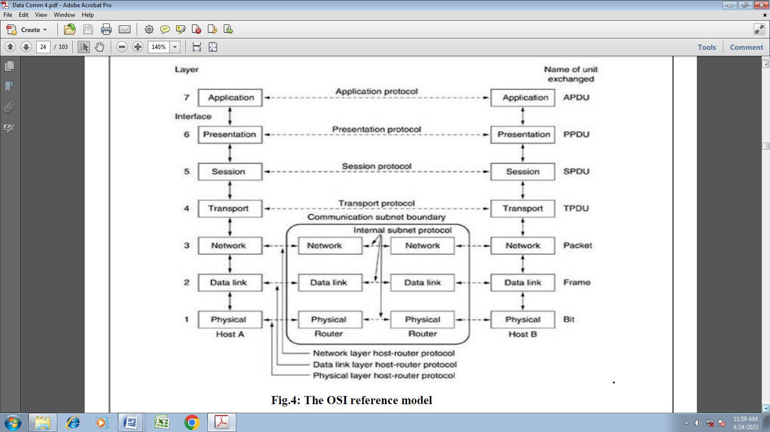
The OSI reference model
The lower 4 layers (transport, network, data link and physical —Layers 4, 3, 2, and 1) are concerned with the flow of data from end to end through the network. The upper four layers of the OSI model (application, presentation and session—Layers 7, 6 and 5) are orientated more toward services to the applications. Data is encapsulated with the necessary protocol information as it moves down the layers before network transit.

As with any layered architecture, overhead information is added to a PDU in the form of headers and trailers. Each layer provides a service to the layer above it in the protocol specification. Each layer communicates with the same layer’s software or hardware on other computers.
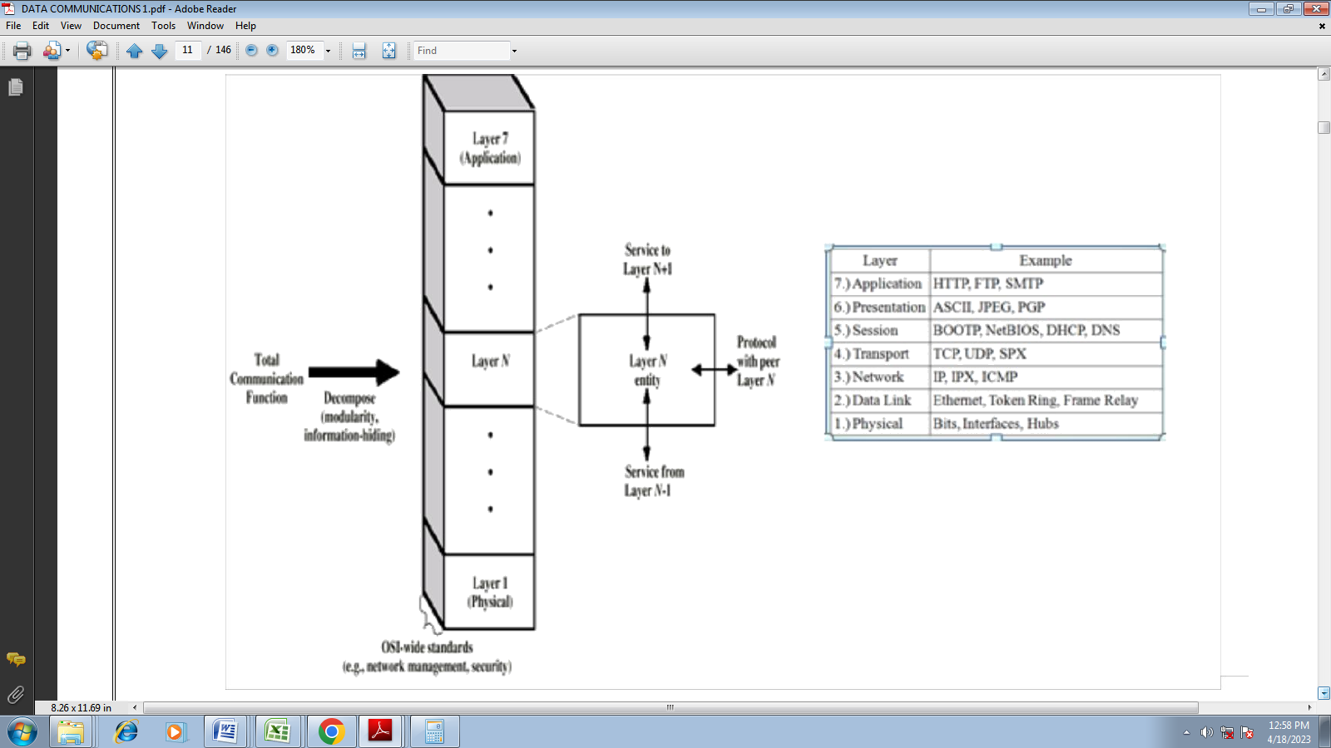
Physical Layer {the physical layer is responsible for transmitting individual bits from one node to the next}
The physical layer is the lowest layer of the OSI hierarchy and coordinates the functions required to transmit a bit stream over a physical medium. It also defines the procedures and functions that physical devices and interfaces have to perform for transmission occur. The physical layer specifies the type of transmission medium and the transmission mode (simplex, half duplex or full duplex) and the physical, electrical, functional and procedural standards for accessing data communication networks.
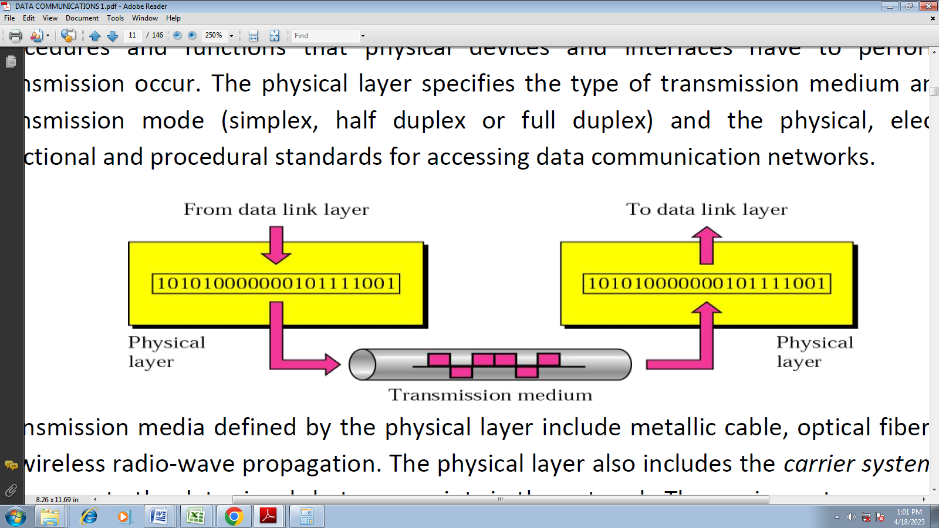
Transmission media defined by the physical layer include metallic cable, optical fiber cable or wireless radio-wave propagation. The physical layer also includes the carrier system used to propagate the data signals between points in the network. The carrier systems are simply communication systems that carry data through a system using either metallic or optical fiber cables or wireless arrangements such as microwave, satellites and cellular radio systems.
In summary it provides the following service:
- Data encoding
- Physical medium attachment, accommodating various possibilities in the medium
- Transmission technique
- Physical medium transmission
Data-link Layer {the data link layer is responsible for transmitting frames from one node to the next}
The data link layer transforms the physical layer, a raw transmission facility, to a reliable link and is responsible for node-to-node delivery. It makes the physical layer appear error free to the upper layer (network layer).
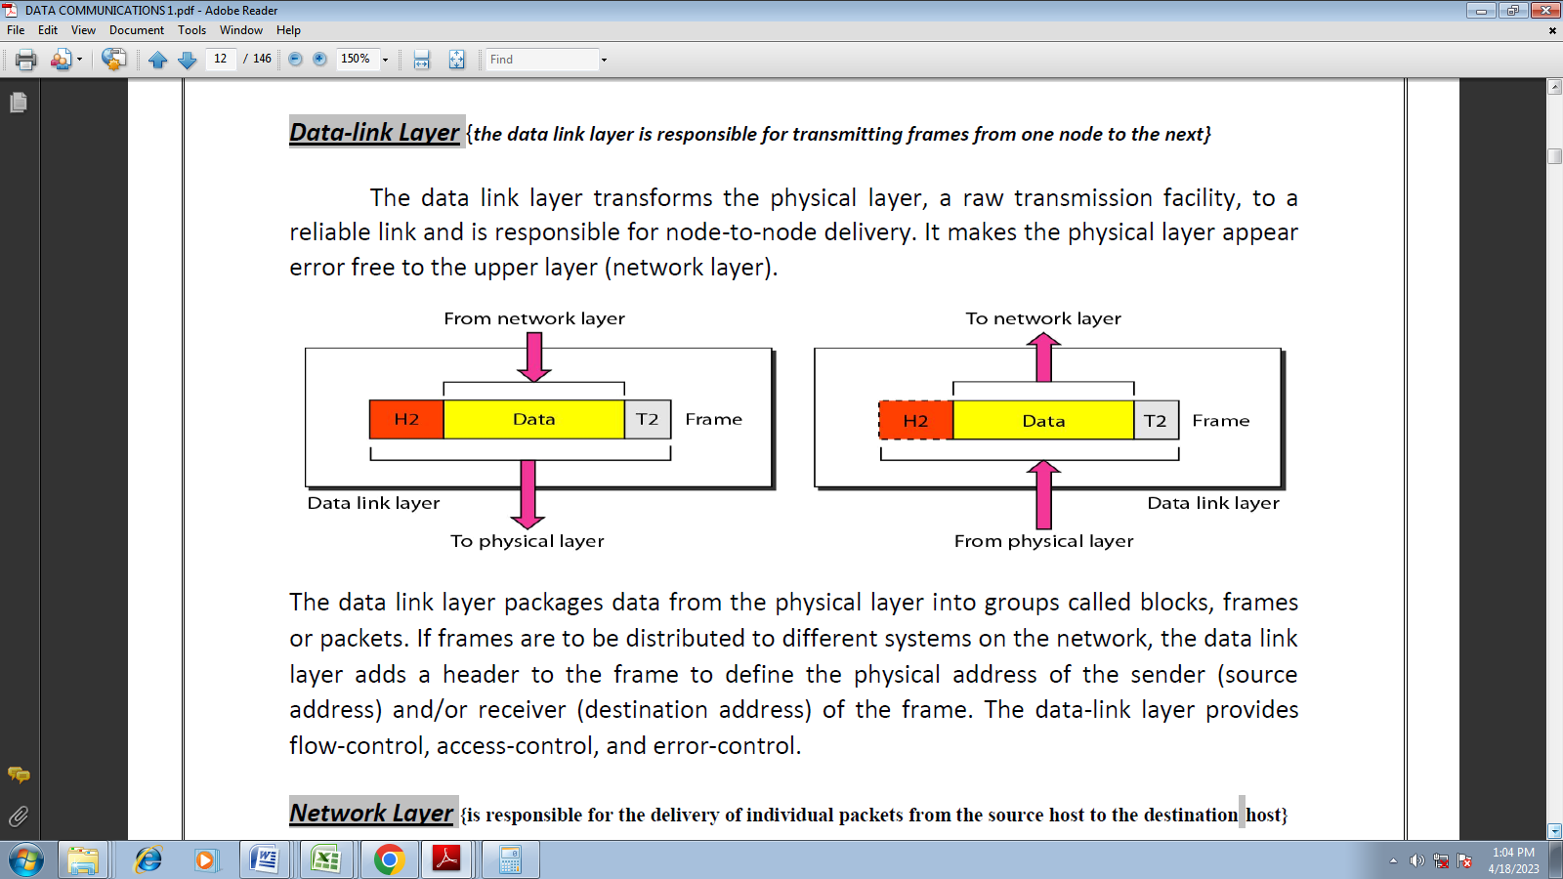
The data link layer packages data from the physical layer into groups called blocks, frames or packets. If frames are to be distributed to different systems on the network, the data link layer adds a header to the frame to define the physical address of the sender (source address) and/or receiver (destination address) of the frame. The data-link layer provides flow-control, access-control, and error-control.
In summary
- The data link layer provides error-free transfer of data frames from one node to another over the physical layer, allowing layers above it to assume virtually error-free transmission over the link.
- Link establishment and termination
- Frame traffic control
- Frame sequencing
- Frame acknowledgment
- Frame delimiting
- Frame error checking
- Media access management
Network Layer {is responsible for the delivery of individual packets from the source host to the destination host}
The network layer provides details that enable data to be routed between devices in an environment using multiple networks, sub networks or both. This is responsible for addressing messages and data so they are sent to the correct destination, and for translating logical addresses and names (like a machine name FLAME) into physical addresses. This layer is also responsible for finding a path through the network to the destination computer.
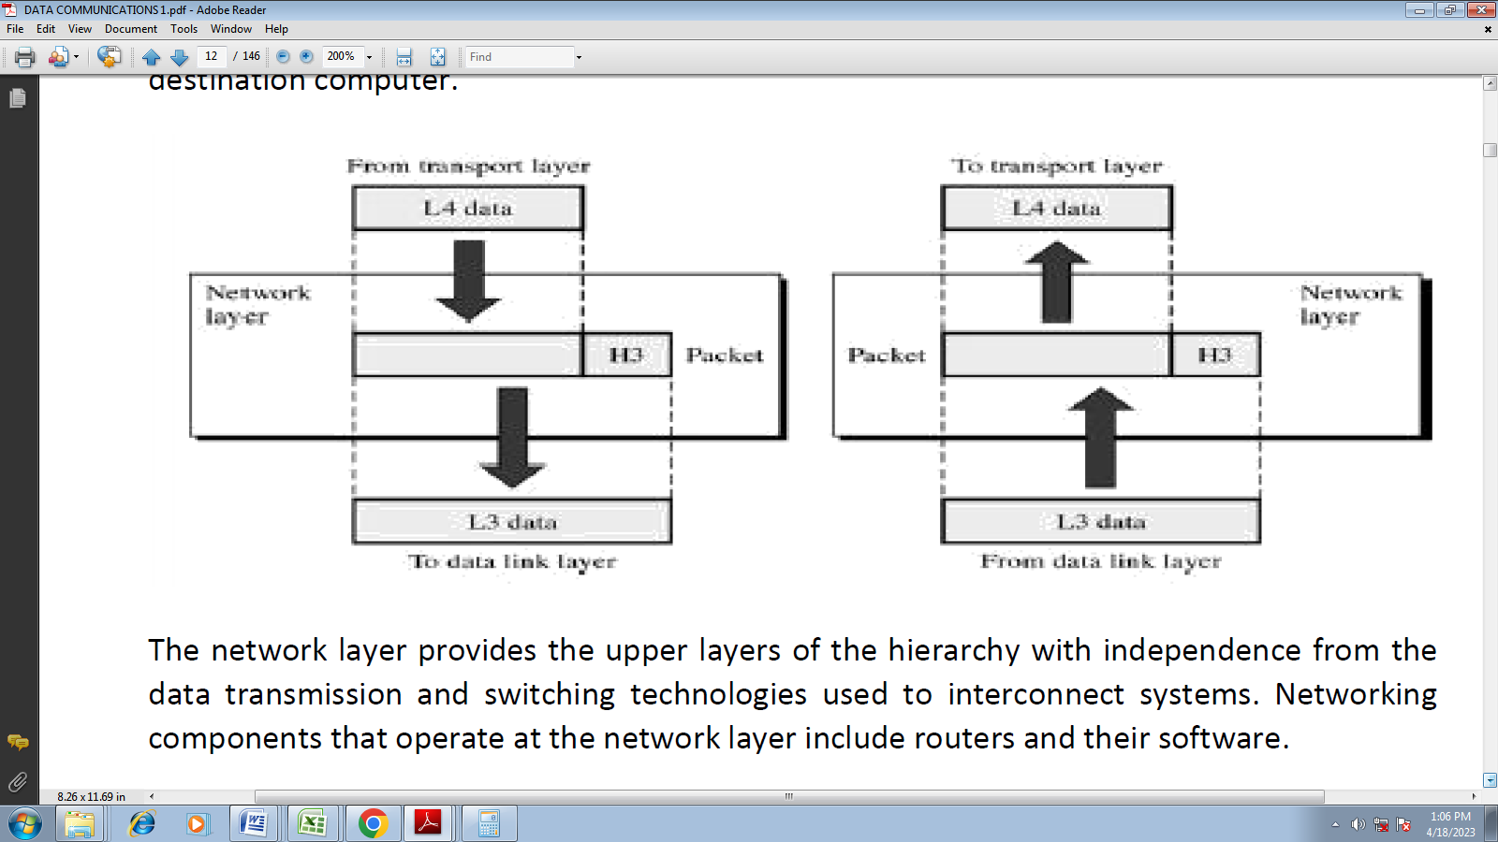
The network layer provides the upper layers of the hierarchy with independence from the data transmission and switching technologies used to interconnect systems. Networking components that operate at the network layer include routers and their software.
In summary
- The network layer controls the operation of the subnet, deciding which physical path the data should take based on network conditions, priority of service, and other factors.
- Routing
- Subnet traffic control
- Frame fragmentation.
- Logical-physical address mapping
- Subnet usage accounting
Transport Layer {is responsible for delivery of a message from one process to another}
The transport layer controls and ensures the end-to-end integrity of the data message propagated through the network between two devices, providing the reliable, transparent transfer of data between two endpoints.
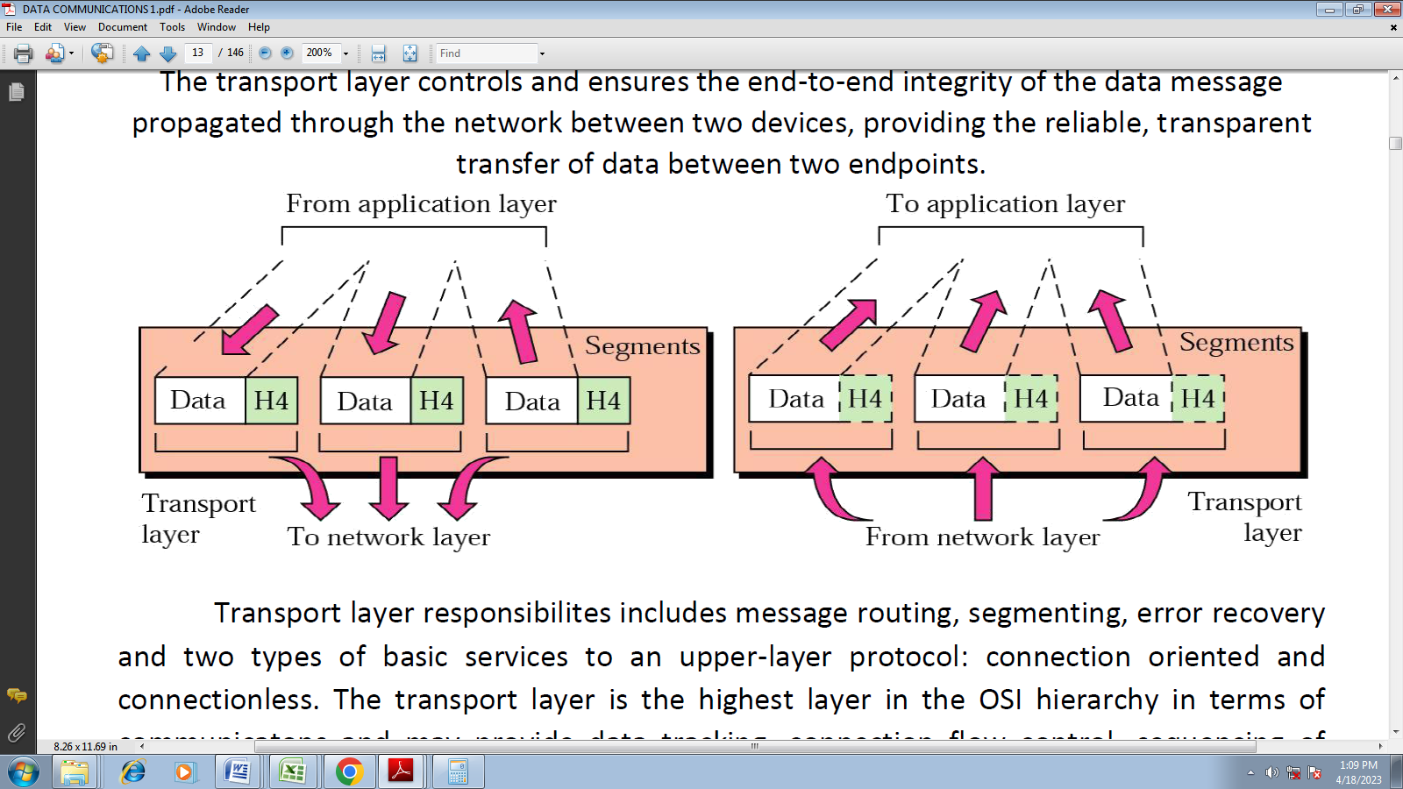
Transport layer responsibilities include message routing, segmenting, error recovery and two types of basic services to an upper-layer protocol: connection oriented and connectionless. The transport layer is the highest layer in the OSI hierarchy in terms of communications and may provide data tracking, connection flow control, sequencing of data, error checking, and application addressing and identification.
In summary
- The transport layer ensures that messages are delivered error-free, in sequence, and with no losses or duplications. It relieves the higher layer protocols from any concern with the transfer of data between them and their peers.
- Message segmentation
- Message acknowledgment
- Message traffic control
- Session multiplexing
Session Layer {responsible for dialog control and synchronization}
Session layer, sometimes called the dialog controller provides mechanism for controlling the dialogue between the two end systems. It defines how to start, control and end conversations (called sessions) between applications.
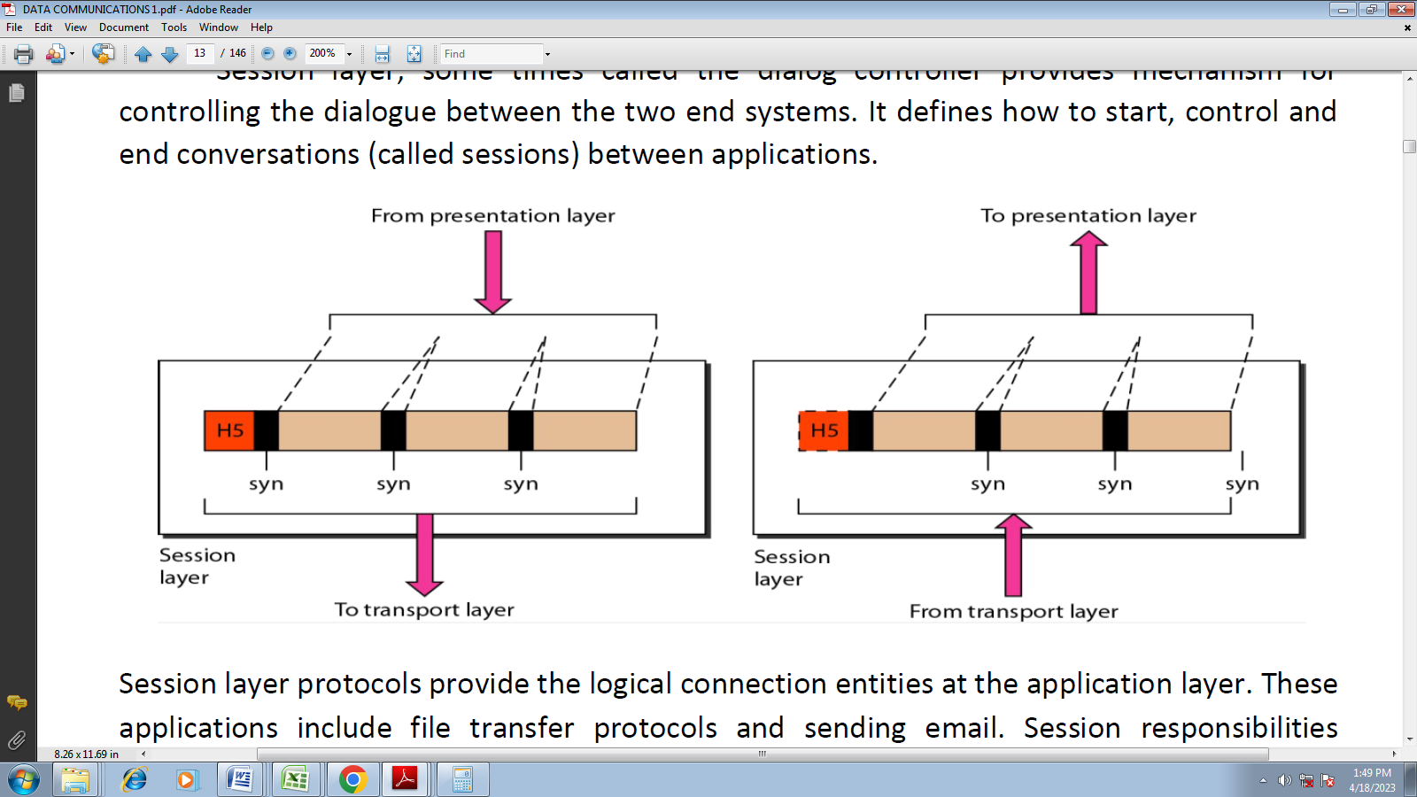
Session layer protocols provide the logical connection entities at the application layer. These applications include file transfer protocols and sending email. Session responsibilities include network log-on and log-off procedures and user authentication. Session layer characteristics include virtual connections between applications, entities, synchronization of data flow for recovery purposes, creation of dialogue units and activity units, connection parameter negotiation, and partitioning services into functional groups.
In summary
- The session layer allows session establishment between processes running on different stations.
- Session establishment, maintenance and termination: allows two application processes on different machines to establish, use and terminate a connection, called a session.
- Session support: performs the functions that allow these processes to communicate over the network, performing security, name recognition, logging, and so on.
Presentation Layer {responsible for translation, compression, and encryption}
The presentation layer provides independence to the application processes by addressing any code or syntax conversion necessary to present the data to the network in a common communications format. It specifies how end-user applications should format the data.
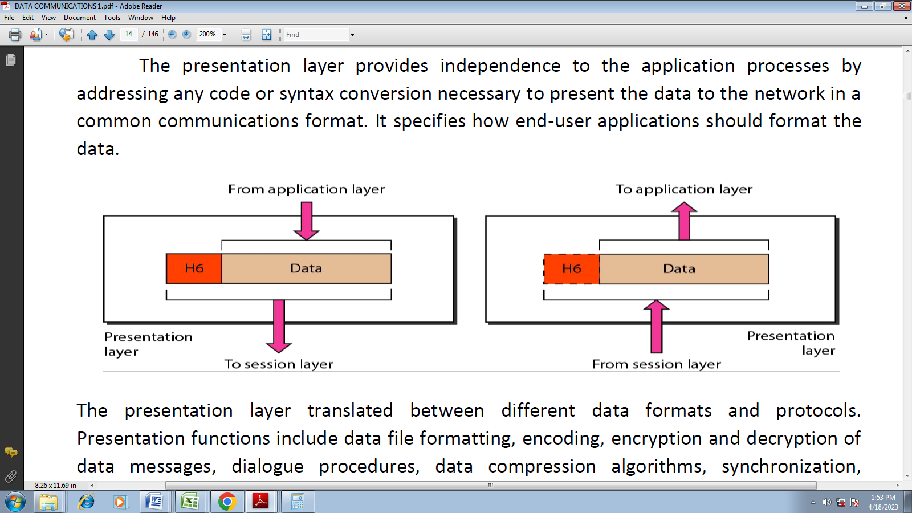
The presentation layer translated between different data formats and protocols.
Presentation functions include data file formatting, encoding, encryption and decryption of data messages, dialogue procedures, data compression algorithms, synchronization, interruption, and termination.
In summary:
- The presentation layer formats the data to be presented to the application layer. It can be viewed as the translator for the network.
- Character code translation: for example, ASCII to EBCDIC.
- Data conversion: bit order, CR-CR/LF, integer, floating point, and so on.
- Data compression: reduces the number of bits that need to be transmitted on the network.
- Data encryption: encrypt data for security purposes. For example, password encryption.
Application Layer {responsible for providing services to the user}
The application layer is the highest layer in the hierarchy and is analogous to the general manager of the network by providing access to the OSI environment. The applications layer provides distributed information services and controls the sequence of activities within and application and also the sequence of events between the computer application and the user of another application.
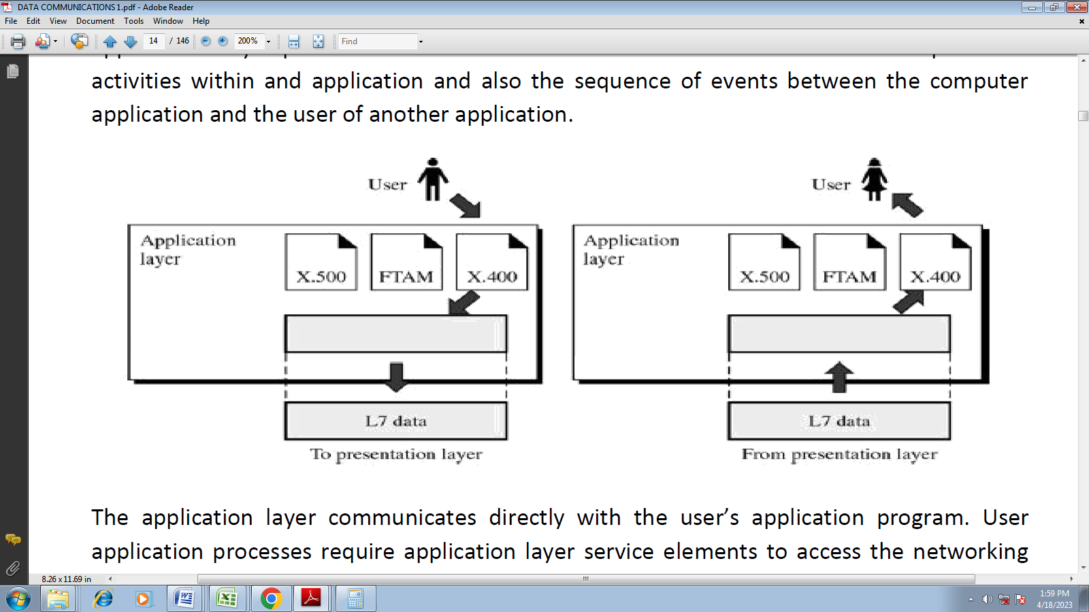
The application layer communicates directly with the user’s application program. User application processes require application layer service elements to access the networking environment. The service elements are of two types: CASEs (common application service elements) satisfying particular needs of application processes like association control, concurrence and recovery. The second type is SASE (specific application service elements) which include TCP/IP stack, FTP, SNMP, Telnet and SMTP.
In summary:
- The application layer serves as the window for users and application processes to access network services.
- Resource sharing and device redirection
- Remote file access
- Remote printer access
- Inter-process communication
- Network management
- Directory services
- Electronic messaging (such as mail)
- Network virtual terminals
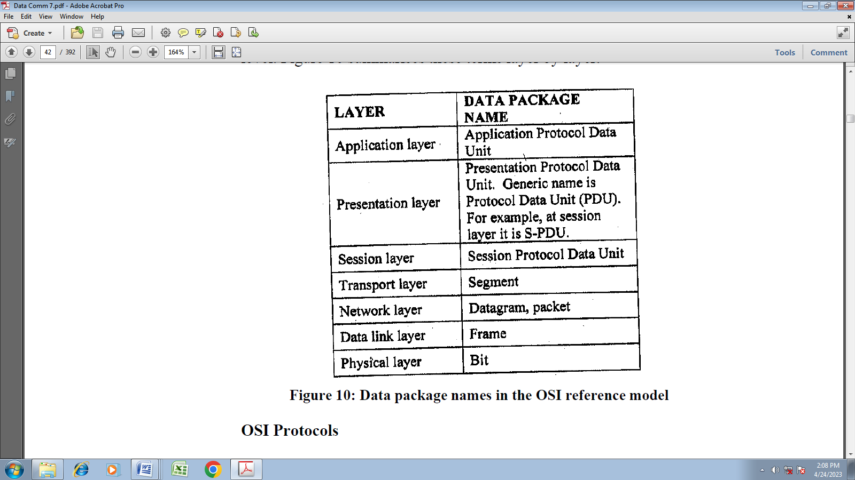
The TCP/IP Reference Model:
Internet uses TCP/IP protocol suite, also known as Internet suite. This defines Internet Model which contains four layered architecture. OSI Model is general communication model but Internet Model is what the internet uses for all its communication. The major design goals of this model were,
1. To connect multiple networks together so that they appear as a single network.
2. To survive after partial subnet hardware failures.
3. To provide a flexible architecture.
Unlike OSI reference model, TCP/IP reference model has only 4 layers. They are,

1. Host-to-Network Layer

2. Internet Layer
3. Transport Layer

4. Application Layer
Host-to-Network Layer:

The TCP/IP reference model does not really say much about what happens here, except to point out that the host has to connect to the network using some protocol so it can send IP packets to it. This protocol is not defined and varies from host to host and network to network.
Link Layer/ Host-to-Network Layer: This layer provides mechanism of sending and receiving actual data. Unlike its OSI Model counterpart, this layer is independent of underlying network architecture and hardware.
Internet Layer:

This layer, called the internet layer, is the linchpin that holds the whole architecture together. Its job is to permit hosts to inject packets into any network and have they travel independently to the destination (potentially on a different network). They may even arrive in a different order than they were sent, in which case it is the job of higher layers to rearrange them, if in-order delivery is desired. Note that ''internet'' is used here in a generic sense, even though this layer is present in the Internet. The internet layer defines an official packet format and protocol called IP (Internet Protocol). The job of the internet layer is to deliver IP packets where they are supposed to go. Packet routing is clearly the major issue here, as is avoiding congestion. For these reasons, it is reasonable to say that the TCP/IP internet layer is similar in functionality to the OSI network layer.

The Transport Layer:

The layer above the internet layer in the TCP/IP model is now usually called the transport layer. It is designed to allow peer entities on the source and destination hosts to carry on a conversation, just as in the OSI transport layer. Two end-to-end transport protocols have been defined here. The first one, TCP (Transmission Control Protocol), is a reliable connection- oriented protocol that allows a byte stream originating on one machine to be delivered without error on any other machine in the internet. It fragments the incoming byte stream into discrete messages and passes each one on to the internet layer. At the destination, the receiving TCP process reassembles the received messages into the output stream. TCP also handles flow control to make sure a fast sender cannot swamp a slow receiver with more messages than it can handle.
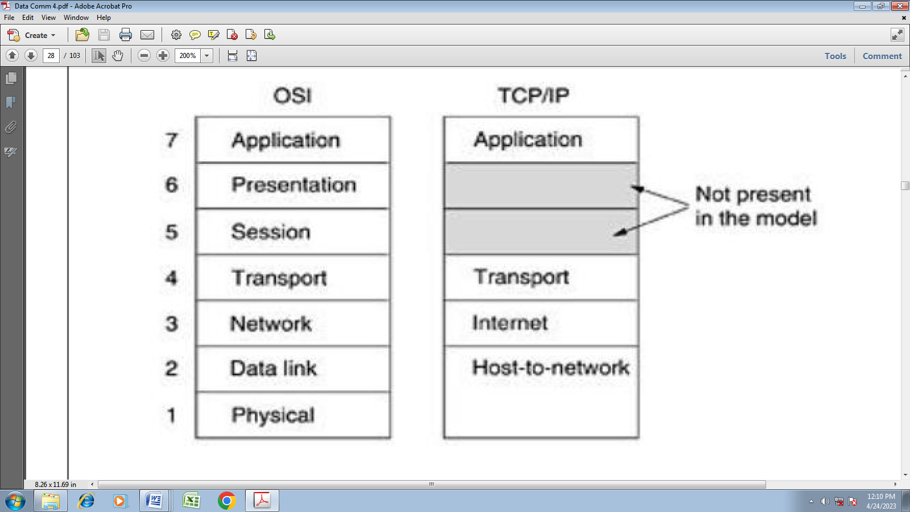
The TCP/IP reference model.
The second protocol in this layer, UDP (User Datagram Protocol), is an unreliable, connectionless protocol for applications that do not want TCP's sequencing or flow control and wish to provide their own. It is also widely used for one-shot, client-server-type request-reply queries and applications in which prompt delivery is more important than accurate delivery, such as transmitting speech or video. The relation of IP, TCP, and UDP is shown below. Since the model was developed, IP has been implemented on many other networks.
In summary Transport Layer defines how data should flow between hosts. Major protocol at this layer is Transmission Control Protocol (TCP). This layer ensures data delivered between hosts is in-order and is responsible for end- to-end delivery.
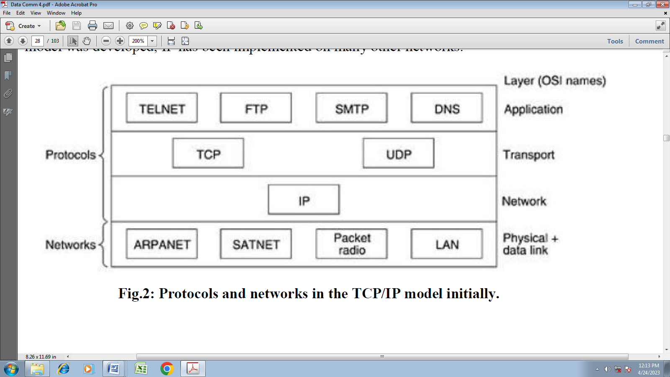
Protocols and networks in the TCP/IP model initially.
The Application Layer:
The TCP/IP model does not have session or presentation layers. On top of the transport layer is the application layer. It contains all the higher-level protocols. The early ones included virtual terminal (TELNET), file transfer (FTP), and electronic mail (SMTP), as shown in Fig. above. The virtual terminal protocol allows a user on one machine to log onto a distant machine and work there. The file transfer protocol provides a way to move data efficiently from one machine to another. Electronic mail was originally just a kind of file transfer, but later a specialized protocol (SMTP) was developed for it. Many other protocols have been added to these over the years: the Domain Name System (DNS) for mapping host names onto their network addresses, NNTP, the protocol for moving USENET news articles around, and HTTP, the protocol for fetching pages on the World Wide Web, and many others.
In Summary: Application Layer defines the protocol which enables user to interact with the network. For example, FTP, HTTP etc.
Comparison of the OSI and TCP/IP Reference Models:

The OSI and TCP/IP reference models have much in common. Both are based on the concept of a stack of independent protocols. Also, the functionality of the layers is roughly similar. For example, in both models the layers up through and including the transport layer are there to provide an end-to-end, network-independent transport service to processes wishing to communicate. These layers form the transport provider. Again in both models, the layers above transport are application-oriented users of the transport service. Despite these fundamental similarities, the two models also have many differences. Three concepts are central to the OSI model:

1. Services.

2. Interfaces.

3. Protocols.

Probably the biggest contribution of the OSI model is to make the distinction between these three concepts explicit. Each layer performs some services for the layer above it. The service definition tells what the layer does, not how entities above it access it or how the layer works. It defines the layer's semantics.
A layer's interface tells the processes above it how to access it. It specifies what the parameters are and what results to expect. It, too, says nothing about how the layer works inside finally, the peer protocols used in a layer are the layer's own business. It can use any protocols it wants to, as long as it gets the job done (i.e., provides the offered services). It can also change them at will without affecting software in higher layers.
The TCP/IP model did not originally clearly distinguish between service, interface, and protocol, although people have tried to retrofit it after the fact to make it more OSI-like. For example, the only real services offered by the internet layer are SEND IP PACKET and RECEIVE IP PACKET.
As a consequence, the protocols in the OSI model are better hidden than in the TCP/IP model and can be replaced relatively easily as the technology changes. Being able to make such changes is one of the main purposes of having layered protocols in the first place. The OSI reference model was devised before the corresponding protocols were invented. This ordering means that the model was not biased toward one particular set of protocols, a fact that made it quite general. The downside of this ordering is that the designers did not have much experience with the subject and did not have a good idea of which functionality to put in which layer. Another difference is in the area of connectionless versus connection-oriented communication. The OSI model supports both connectionless and connection-oriented communication in the network layer, but only connection-oriented communication in the transport layer, where it counts (because the transport service is visible to the users). The TCP/IP model has only one mode in the network layer (connectionless) but supports both modes in the transport layer, giving the users a choice. This choice is especially important for simple request-response protocols.
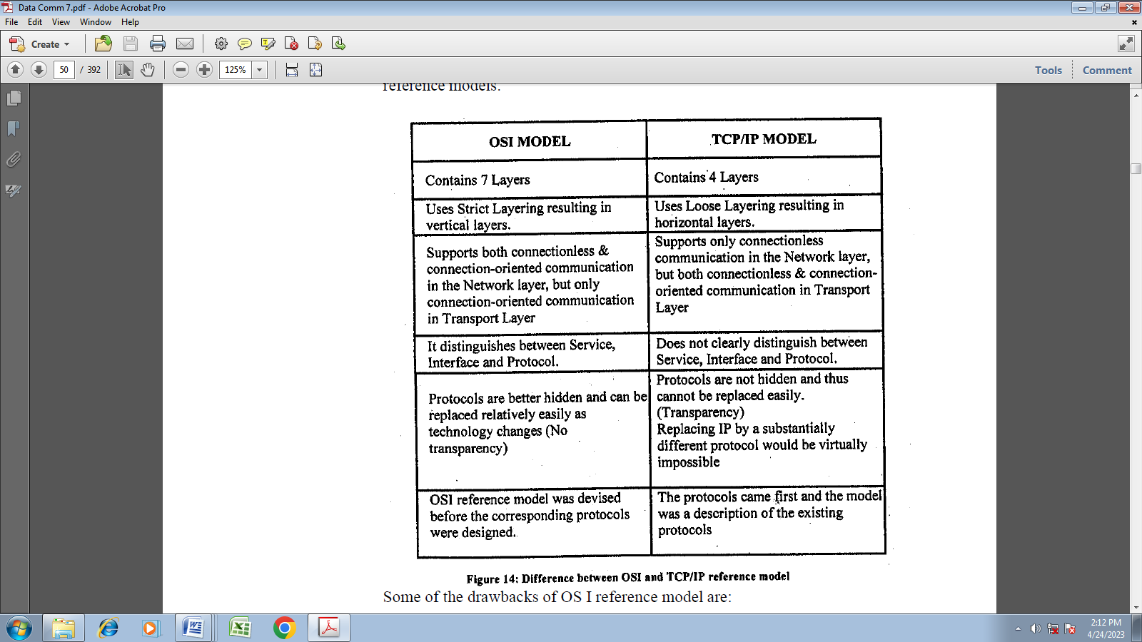
Some of the drawbacks of OSI reference model are:

- All layers are not roughly, of equal size and complexity. In practice, the session layer and presentation layer are absent from many existing architectures.
- Some functions like addressing, flow control, retransmission are duplicated at each layer, resulting in deteriorated performance.
- The initial specification of the OSI model ignored the connectionless model, thus, leaving much of the LANs behind.
Some of the drawbacks of TCP/IP model are:

- TCP/IP model does not clearly distinguish between the concepts of service, interface, and protocol.
- TCP/IP model is not a general model and therefore it cannot be used to describe any protocol other than TCP/IP.
- TCP/IP model does not distinguish or even mention the Physical or the Data link layer. A proper model should include both these layers as separate.
Routing
Routing is the process of selecting a path for traffic in a network or between or across multiple networks. Broadly, routing is performed in many types of networks, including circuit-switched networks, such as the public switched telephone network (PSTN), and computer networks, such as the Internet.
Router
A router is a device that connects two or more packet-switched networks or subnetworks. It serves two primary functions: managing traffic between these networks by forwarding data packets to their intended IP addresses, and allowing multiple devices to use the same Internet connection.
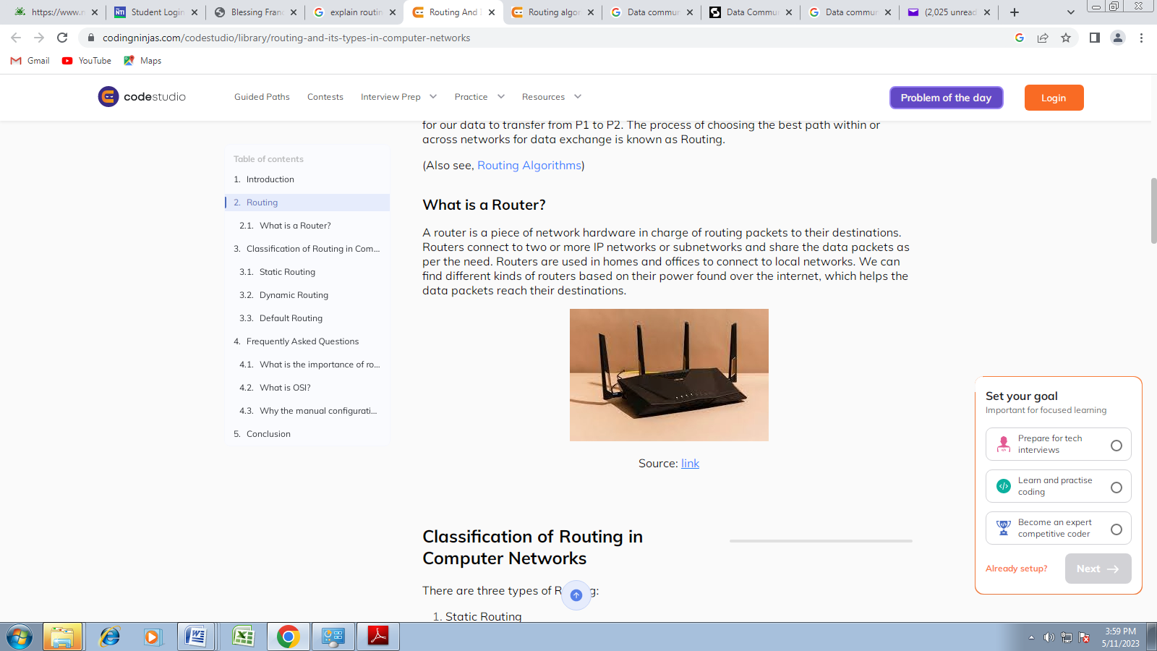
In simple terms, suppose P1 is our network, and we want to send data to P2, and there are many networks between these two. Our network requires a router to choose the best path for our data to transfer from P1 to P2. The process of choosing the best path within or across networks for data exchange is known as Routing.

Classification of Routing in Computer Networks
There are three types of Routing:
- Static Routing
- Default Routing
- Dynamic Routing
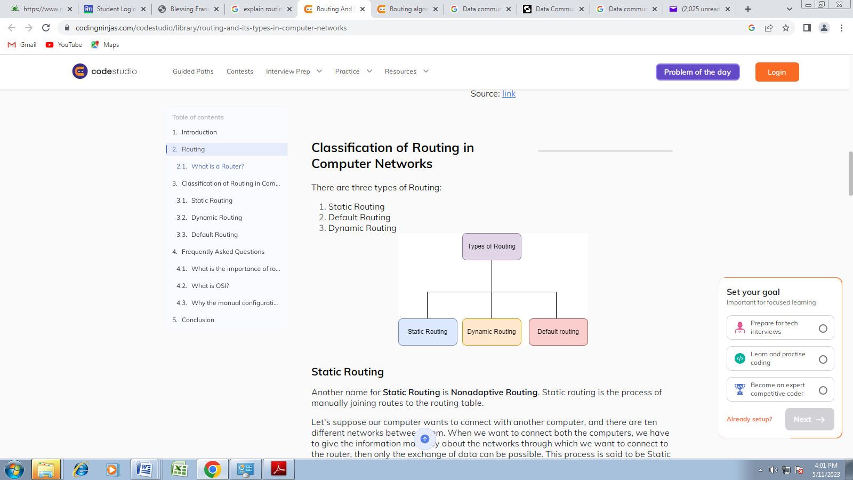

Static Routing
Another name for Static Routing is Nonadaptive Routing. Static routing is the process of manually joining routes to the routing table.
Let's suppose our computer wants to connect with another computer, and there are ten different networks between them. When we want to connect both the computers, we have to give the information manually about the networks through which we want to connect to the router, then only the exchange of data can be possible. This process is said to be Static Routing.
Advantages:
- The administrator manually sets it up.
- It is safe and quick.
- There is no bandwidth usage between routers.
- Because there is no routing overhead for the router CPU, a less expensive router can be used for routing.
Disadvantages:
- Utilized in small network
- Everything has to be set up manually.

Dynamic Routing
Another name of Dynamic Routing is Adaptive Routing. Dynamic routing automatically adjusts routes based on the current state of the route in the routing table. Protocols are used in dynamic routing to discover network destinations and the routes that will take them there. The best examples of dynamic routing protocols are RIP and OSPF. If one of the network routes fails, it will make automatic adjustments to reach the network's destination.
Let's suppose our computer wants to connect with another computer. There are ten different networks between them, so the path they have to follow while connecting is chosen automatically, assuring security, collision, hacking, and many more.
Advantages:
- There is no need to understand the networks.
- Its setup is easy.
- Administrator work is less.
- It is used for big organizations.
- It is more effective at determining the best path in response to changes in the condition or topology.
Disadvantages:
- More bandwidth is consumed when interacting with other neighbours.
- Dynamic routing necessitates the use of more resources such as CPU, RAM, and bandwidth. That's why it's more expensive.
- Dynamic routing introduces more complexity to the network, especially during implementation.

Default Routing
It is the method in which the router is set up to send all packets to a single router (next hop). It makes no difference to which network the packet belongs to; it is forwarded to the router that is set to default routing. It is typically used in conjunction with stub routers. A stub router only has one route to all other networks.
It is set up for unknown locations or end locations. It is the least preferred Routing. It helps in minimizing the size of your routing table.
Advantages:
- If there are no fixed routes in the routing table, the default route can be helpful. The default route is used for all packet traffic with an unknown destination in the routing table.
- It is suitable for packet filtering, firewalling, and proxy servers as it is configured for unknown destinations.
Disadvantages:
- If the network is overly complex, the setup will also be difficult.
- The network topology determines it.

What is a Routing Algorithm in Computer Network
A routing algorithm is a way to establish the path for data packets. The path is from the source to the destination. It helps in leading internet traffic.
When a data packet leaves its origin, it can take one of many different paths. It computes the best path (least-cost path) to send the data.

Classification of Routing Algorithms
There are mainly two types:
a.) Adaptive: It is also referred to as dynamic routing. The traffic and topology determine the decisions and select routes.
b.) Non-adaptive: It is also known as static routing. It is free of network topology and traffic.
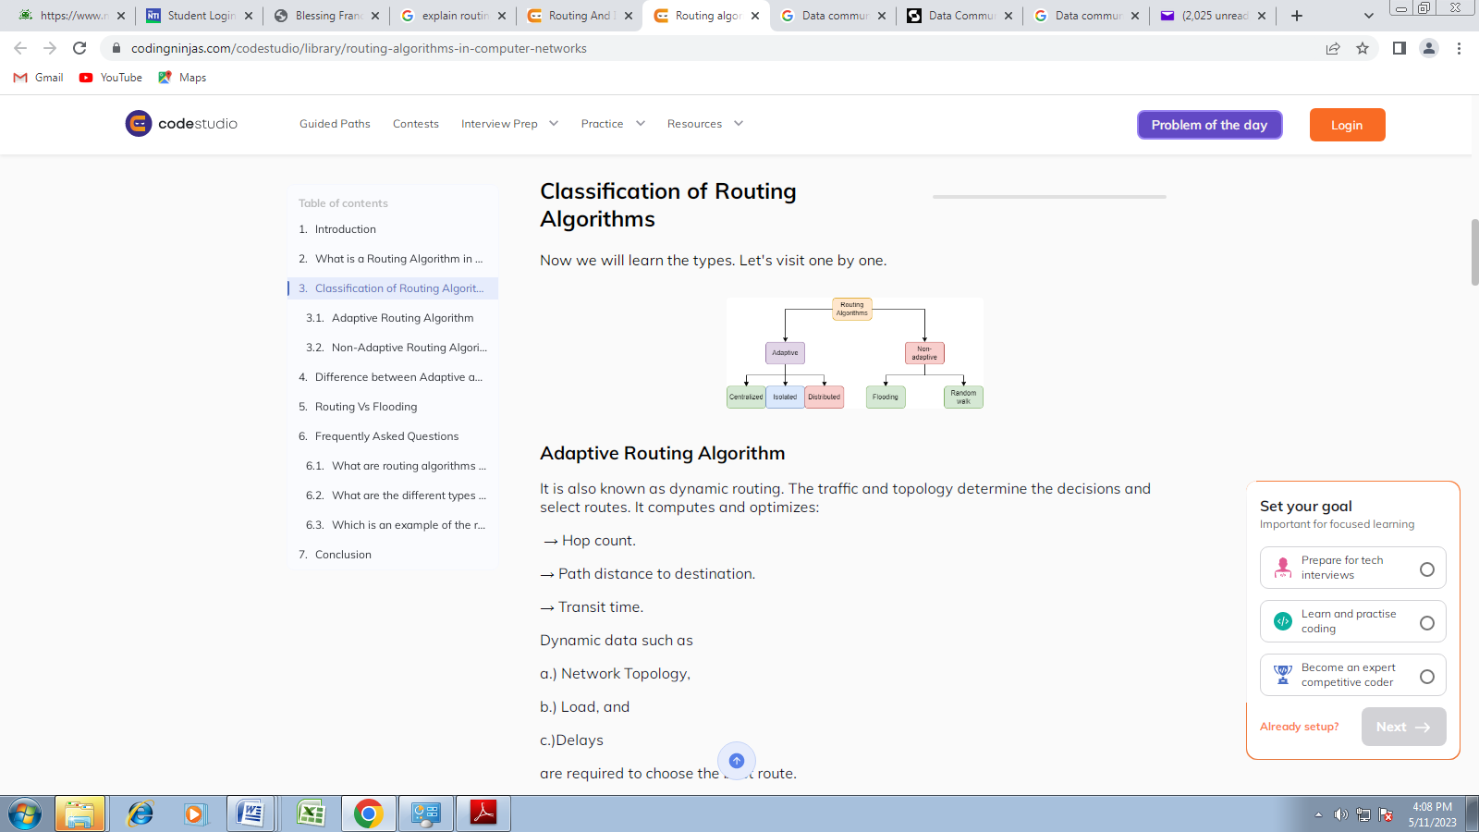

Adaptive Routing Algorithm
  - Adaptive: It is also referred to as dynamic routing. The traffic and topology determine the decisions and select routes
These are of three types:
Centralized Routing:- It finds the best least-cost path to transfer data packets. The complete network topology info is used. As a result, it is also known as the global routing algo. Before calculating routes, the connection between the nodes and input as link cost is set.
The centralized node contains all of the network topology data. It is needed to make correct routing decisions. If it fails, the entire network fails. The main benefit is that only one node will have information about the entire network.
Isolated Routing:- It derives routing info from local info rather than from neighbour nodes. Routing decisions are based solely on local info, with no data from other nodes. The node will not know the link status.
Distribution Routing:- It is also known as decentralized routing or distance vector routing. It finds the least-cost route. The node that sends the data packets receives info from other nodes. Then it determines how to send them to their target. A delay in the time interval of receiving info results in a delay in sending data.
The node that sends the data packets does not contain any info about the complete route. It includes info on the cheapest path for sending data packets.

Non-Adaptive Routing Algorithm
It is also known as static routing. This algorithm's routing of data packets is free of network topology and traffic. When the network boots, the routers save the routing info. The best route will be selected in advance and will not change.
These are two types:
Flooding Routing:- In this case, all incoming data packets are received by all outgoing links except the one from which the packet started. The loop links may generate duplicate data. We can fix this issue by using:
a.) Sequential numbers.
b.) Spanning trees.
c.) Hop count.
Random walk Routing:- The data packets are transferred from host to host to one of its neighbors. The packet arrives at the destination randomly. It is a robust method. It is implemented by sending packets onto the least queued link.

Difference between Adaptive and Non-Adaptive Routing Algorithm
Basis Of Comparison | Adaptive Routing algorithm | Non-Adaptive Routing algorithm
Define | Adaptive routing is a network routing algorithm that dynamically changes the path of data based on the current network conditions, such as congestion or failures. | Non-adaptive routing is a network routing algorithm that uses a predetermined or fixed path for data to travel through the network, regardless of the current network conditions.
Usage | Adaptive routing is commonly used in large, complex networks to optimize data delivery, minimize congestion, and reroute data in the event of network failures. | Non-adaptive routing is often used in smaller, less complex networks where network conditions are relatively stable and predictable, and where routing decisions can be made ahead of time.
Categorization | Adaptive routing algorithms can be categorized as distributed or centralizedsed on whether the routing decisions are made locally by individual nodes or globally by a central control entity. | Non-adaptive routing algorithms can be categorized as static or dynamic, based on whether the predetermined path is fixed or can be changed in response to changes in network conditions.
Complexity | Adaptive routing can be complex, as it requires the exchange of information between nodes and the use of sophisticated algorithms to make routing decisions in real-time based on changing network conditions. | They are simple as compared to the Adaptive routing algorithms.

Routing Vs Flooding
Basis Of Comparison | Routing algorithm | Flooding
Definition | A set of computational rules that determine the best path for data transmission between network devices from a source to a destination in a computer network. | Flooding is a network communication method in which a packet is transmitted to all network devices, without considering the destination address, causing network congestion and redundancy.
Duplicacy | It does not generate duplicate data packets. | Duplicacy in flooding occurs when a packet is transmitted multiple times to the same network device, either due to looped network paths or the absence of a mechanism to prevent packet duplication.
Optimal Path | It finds the shortest path, which may or may not be the optimal path. | It always takes the shortest path.
Traffic | It does not generate extra traffic. | It generates a large amount of traffic, which may reduce network throughput.

NETWORK SECURITY
Network security is a broad term that covers a multitude of technologies, devices and processes. In its simplest term, it is a set of rules and configurations designed to protect the integrity, confidentiality and accessibility of computer networks and data using both software and hardware technologies. Every organization, regardless of size, industry or infrastructure, requires a degree of network security solutions in place to protect it from the ever-growing landscape of cyber threats in the wild today.
Network security typically consists of three different controls: physical, technical and administrative. Here is a brief description of the different types of network security control and how each control works.
- Physical Network Security
Physical security controls are designed to prevent unauthorized personnel from gaining physical access to network components such as routers, cabling cupboards and so on. Controlled access, such as locks, biometric authentication and other devices, is essential in any organization.
- Technical Network Security
Technical security controls protect data that is stored on the network or which is in transit across, into or out of the network. Protection is twofold; it needs to protect data and systems from unauthorized personnel, and it also needs to protect against malicious activities from employees.
- Administrative Network Security
Administrative security controls consist of security policies and processes that control user behavior, including how users are authenticated, their level of access and also how IT staff members implement changes to the infrastructure.
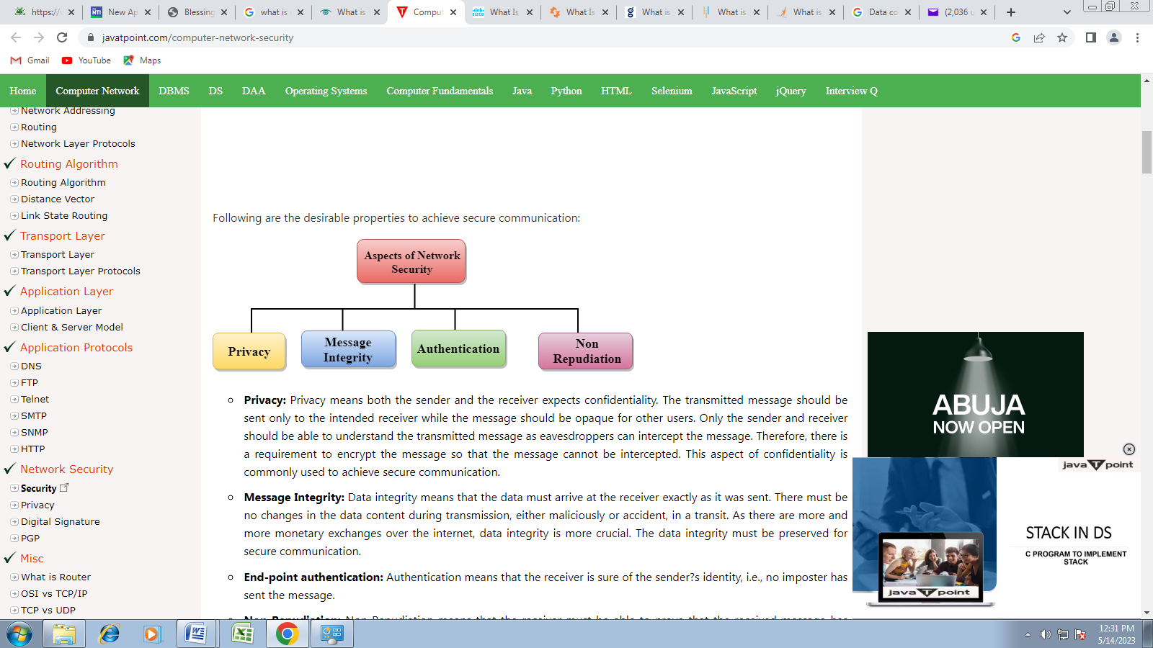
- Privacy: Privacy means both the sender and the receiver expects confidentiality. The transmitted message should be sent only to the intended receiver while the message should be opaque for other users. Only the sender and receiver should be able to understand the transmitted message as eavesdroppers can intercept the message. Therefore, there is a requirement to encrypt the message so that the message cannot be intercepted. This aspect of confidentiality is commonly used to achieve secure communication.
- Message Integrity: Data integrity means that the data must arrive at the receiver exactly as it was sent. There must be no changes in the data content during transmission, either maliciously or accident, in a transit. As there are more and more monetary exchanges over the internet, data integrity is more crucial. The data integrity must be preserved for secure communication.
- End-point authentication: Authentication means that the receiver is sure of the sender’s identity, i.e., no imposter has sent the message.
- Non-Repudiation: Non-Repudiation means that the receiver must be able to prove that the received message has come from a specific sender. The sender must not deny sending a message that he or she send. The burden of proving the identity comes on the receiver. For example, if a customer sends a request to transfer the money from one account to another account, then the bank must have a proof that the customer has requested for the transaction.
Why Do Users Get Attacked (Motives for Attacking an Organization’s or Individual’s Computer).
Before getting into how to secure data from breaches, we must try to understand the motives behind these attacks. By knowing the motives behind the attacks, it’s easy for cyber security professionals to secure the systems. The main motives for attacking an organization’s or individual’s computer are:
- Disrupting a business’ continuity: If a business is disrupted, it causes great harm to the organization in the form of lost profits, fraud, and damage to its reputation.
- Information theft and manipulating data: Hackers take confidential information that they steal from organizations and sell it to individuals or groups on the black market.
- Creating chaos and fear by disrupting critical infrastructure: Cyber terrorists attack a company or a government body to disrupt their services, doing damage that can potentially affect an entire nation.
- Financial loss to the target: Hackers attack an organization or business and disrupt their services in such a way that the target has to allocate substantial funds to repair the damage.
- Achieving a state’s military objectives: Rival nations continuously keep an eye on each other and sometimes employ cybercriminal tactics to steal military secrets.
- Demanding ransom: The hackers employ ransom ware to block a website or servers, releasing control only after a ransom is paid.
- Damaging the reputation of target: The hacker may have personal reasons to attack an organization or individual so that their reputation suffers.
- Propagating religious or political beliefs: Hackers may infiltrate websites to promote religious dogma or a certain political agenda, usually to sway voters to vote a certain way.

Types of Attacks
There are many kinds of attacks available to the dedicated hacker. These are among the most famous and frequent types of attacks.

1. Denial of service (DDoS):
This is an attack used to restrict the user’s access to the system resources by flooding the server with useless traffic. The botmaster commands all the bots to access a resource at the same time so that the resource gets hopelessly jammed up. Then, if a legitimate user wants to access that same resource, they will not be able to do so. This is illustrated below:
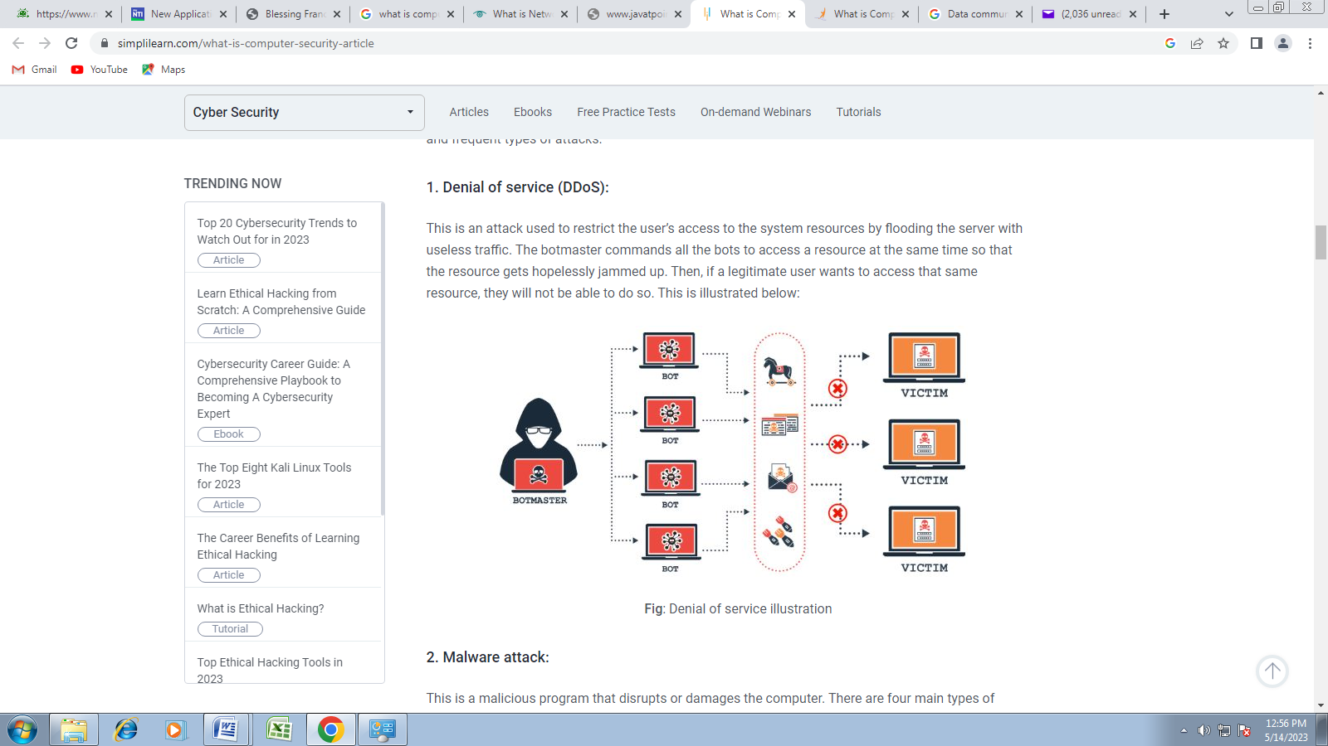Denial of service illustration

2. Malware attack:
This is a malicious program that disrupts or damages the computer. There are four main types of malware:
- Keylogger: Keylogger records all the hits on the targeted keyboard. Most hackers use it to get passwords and account details.
- Virus: A computer virus is a malicious code that replicates by copying itself to another program or document and changes how a computer works. The virus, such as the Melissa virus, requires someone to knowingly or unknowingly spread the infection without the knowledge or permission of a user or system administrator.
- Worms: This is a standalone program that runs independently and infects the system. One of the more popular examples is W32.Alcra.F. The worm propagates itself through network share devices.
- Trojan horse: This is a malicious code that takes over your computer. This code can damage or steal information from your computer.
3. Man in the middle:
Say, for example, you want to do an online transaction. You connect to your bank and conduct the payment. This is illustrated in the below image
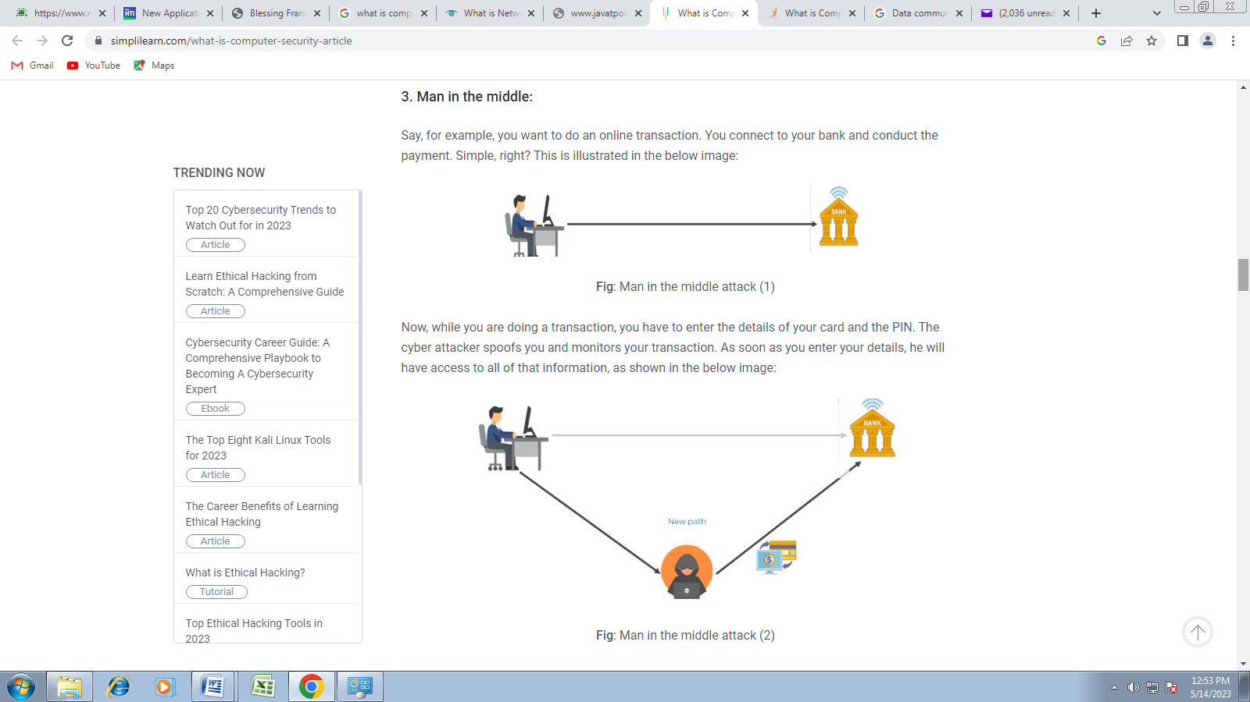
Man in the middle attack
Now, while you are doing a transaction, you have to enter the details of your card and the PIN. The cyber attacker spoofs you and monitors your transaction. As soon as you enter your details, he will have access to all of that information, as shown in the below image
Man in the middle attack

4. Phishing:
The attacker sends bait, often in the form of an email. It encourages people to share their details. For example, you get an email like this:
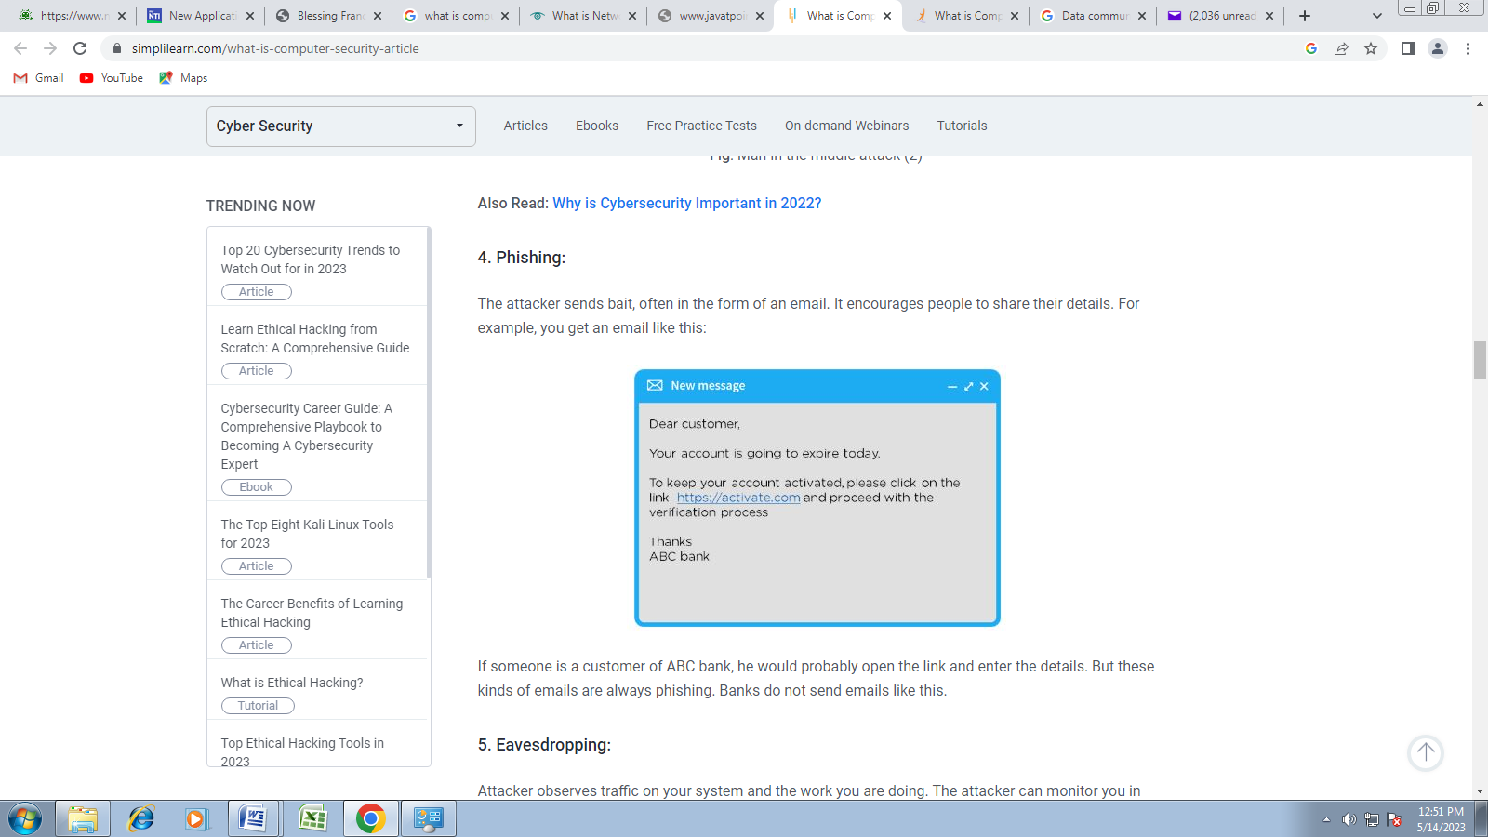
If someone is a customer of ABC bank, he would probably open the link and enter the details. But these kinds of emails are always phishing. Banks do not send emails like this.
5. Eavesdropping:
Attacker observes traffic on your system and the work you are doing. The attacker can monitor you in three ways:
- Email monitoring
- Which websites you visit
- What items you download
6. SQL injection:
As the name suggests, an SQL injection vulnerability allows an attacker to inject malicious input into a SQL statement. This type of attack happens only on websites. The best example would be www.facebook.com. There is a database stored on the Facebook website. The hackers get into that database and sign in using someone else's username and password.
7. Password attack:
To crack a password or find a password, hackers employ the following techniques:
- Dictionary attack: In this method, they handle every password that is possible through the dictionary
- Brute force: It is a trial and error method used to decode the password or data. This attack takes the most amount of time.
- Keylogger: As the name suggests, keylogger records all the hits on the keyboard. Most people use it to get passwords and account details.
- Shoulder surfing: The attackers observe the user’s keyboard by looking over the user’s shoulder.
- Rainbow table: There are rainbow tables that contain precomputed hash values. Attackers use this table to find the user’s password.
8. Social engineering:
Attackers create social situations that encourage you to share your password. For example, let’s say that you are out of your office, and you get a call. The person says that he is from the IT department and they have found out that your system has been compromised. He asks you to share your password. You might believe him and share your password. However, the caller was, in fact, a hacker, and how he has your password. Now that he has access, he can compromise your organization's data. The best way to avoid the effects of social engineering is to learn your organization’s protocol regarding password sharing.
How Do You Secure Your Computer?
1. Two-way authentication
Two-factor authentication adds a layer of security to the authentication process by making it harder for attackers to gain access to a person's devices or online accounts. For example, when you make online payments, you first have to confirm your card’s cvv number, then you undergo a second confirmation by providing your mobile number.
2. Secure passwords
Create strong passwords so that no one will be able to hack or guess your password.

3. Regular updates
Always keep your system and all its software updated. Many updates contain additional defenses against cyber attacks.

4. Antivirus
Antivirus is a computer program used to prevent, detect, and remove malware. Examples of antivirus include Norton, Quickheal, and McAfee.

5. Firewalls
Firewalls prevent unauthorized Internet users from accessing private networks connected to the Internet, especially intranets.

6. Anti-Phishing Tactics
When you get an email that looks suspicious or has no relation to you, then do the following:
- Do not click on the link in the email.
- Do not provide any personal details if asked.
- Do not open the attached files.
7. Encryption
This is the process of converting ordinary plain text into unintelligible text and vice-versa. Encryption is used in many applications like:
- Banking transactions.
- Computer passwords.
- E-commerce transactions.

Encryption/Decryption
Encryption: Encryption means that the sender converts the original information into another form and sends the unintelligible message over the network.
Decryption: Decryption reverses the Encryption process in order to transform the message back to the original form. The data which is to be encrypted at the sender site is known as plaintext, and the encrypted data is known as ciphertext. The data is decrypted at the receiver site.
There are two types of Encryption/Decryption techniques:
- Privacy with secret key Encryption/Decryption
- Privacy with public key Encryption/Decryption
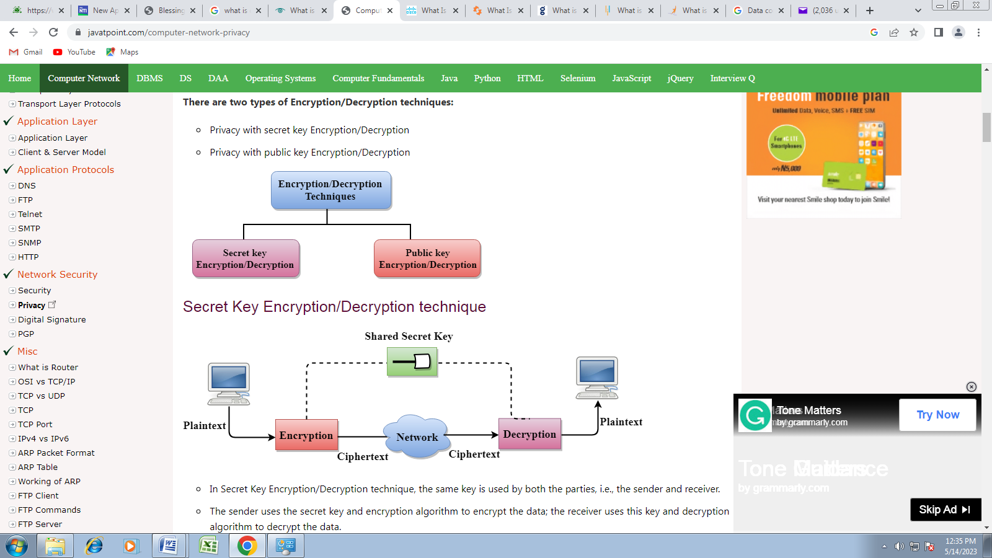
- In Secret Key Encryption/Decryption technique, the same key is used by both the parties, i.e., the sender and receiver.
- The sender uses the secret key and encryption algorithm to encrypt the data; the receiver uses this key and decryption algorithm to decrypt the data.
- In Secret Key Encryption/Decryption technique, the algorithm used for encryption is the inverse of the algorithm used for decryption. It means that if the encryption algorithm uses a combination of addition and multiplication, then the decryption algorithm uses a combination of subtraction and division.
- The secret key encryption algorithm is also known as symmetric encryption algorithm because the same secret key is used in bidirectional communication.
- In secret key encryption/decryption algorithm, the secret code is used by the computer to encrypt the information before it is sent over the network to another computer.
- The secret key requires that we should know which computers are talking to each other so that we can install the key on each computer.
Secret Key Cryptography.

Advantage
- Efficient: The secret key algorithms are more efficient as it takes less time to encrypt the message than to encrypt the message by using a public key encryption algorithm. The reason for this is that the size of the key is small. Due to this reason, Secret Key Algorithms are mainly used for encryption and decryption.

Disadvantages of Secret Key Encryption
- Each pair of users must have a secret key. If the number of people wants to use this method in the world is N, then there are N(N-1)/2 secret keys. For example, for one million people, then there are half billion secret keys.
- The distribution of keys among different parties can be very difficult. This problem can be resolved by combining the Secret Key Encryption/Decryption with the Public Key Encryption/Decryption algorithm.

Public Key Encryption/Decryption technique
- There are two keys in public key encryption: a private key and a public key.
- The private key is given to the receiver while the public key is provided to the public.
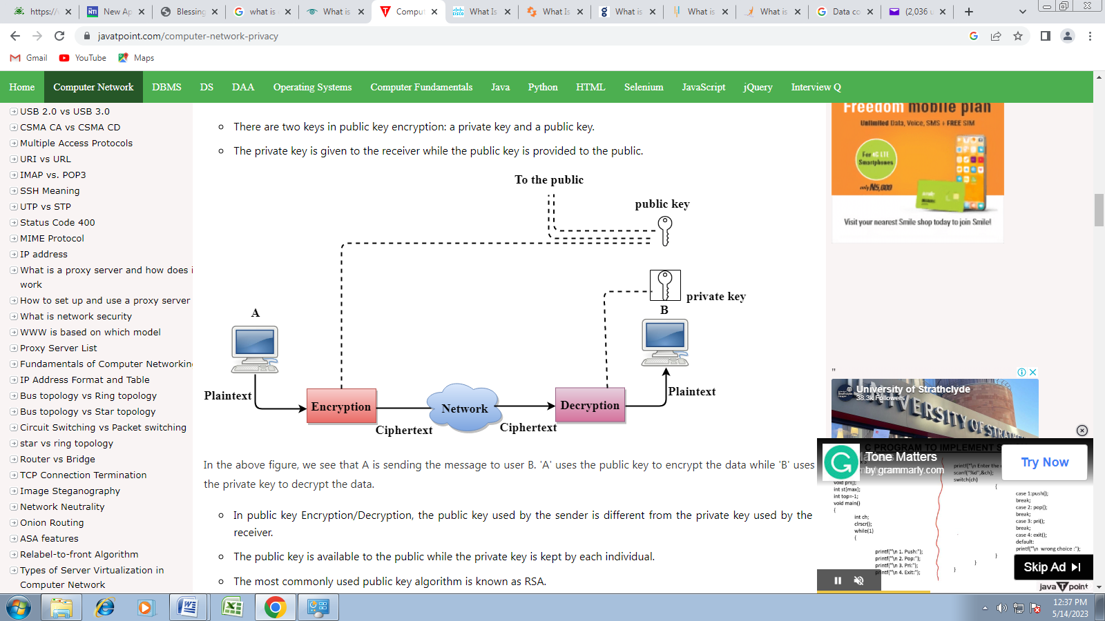
In the above figure, we see that A is sending the message to user B. 'A' uses the public key to encrypt the data while 'B' uses the private key to decrypt the data.
- In public key Encryption/Decryption, the public key used by the sender is different from the private key used by the receiver.
- The public key is available to the public while the private key is kept by each individual.
- The most commonly used public key algorithm is known as RSA.

Advantages of Public Key Encryption
- The main restriction of private key encryption is the sharing of a secret key. A third party cannot use this key. In public key encryption, each entity creates a pair of keys, and they keep the private one and distribute the public key.
- The number of keys in public key encryption is reduced tremendously. For example, for one million users to communicate, only two million keys are required, not a half-billion keys as in the case of secret key encryption.

Disadvantages of Public Key Encryption
- Speed: One of the major disadvantages of the public-key encryption is that it is slower than secret-key encryption. In secret key encryption, a single shared key is used to encrypt and decrypt the message which speeds up the process while in public key encryption, different two keys are used, both related to each other by a complex mathematical process. Therefore, we can say that encryption and decryption take more time in public key encryption.
- Authentication: A public key encryption does not have a built-in authentication. Without authentication, the message can be interpreted or intercepted without the user's knowledge.
- Inefficient: The main disadvantage of the public key is its complexity. If we want the method to be effective, large numbers are needed. But in public key encryption, converting the plaintext into ciphertext using long keys takes a lot of time. Therefore, the public key encryption algorithms are efficient for short messages not for long messages.

Differences b/w Secret Key Encryption & Public Key Encryption
S/N | Basis for Comparison | Secret Key Encryption | Public Key Encryption
1 | Define | Secret Key Encryption is defined as the technique that uses a single shared key to encrypt and decrypt the message. | Public Key Encryption is defined as the technique that uses two different keys for encryption and decryption.
2 | Efficiency | It is efficient as this technique is recommended for large amounts of text. | It is inefficient as this technique is used only for short messages.
3 | Other name | It is also known as Symmetric Key encryption. | It is also known as Asymmetric Key Encryption
4 | Speed | Its speed is high as it uses a single key for encryption and decryption. | Its speed is slow as it uses two different keys, both keys are related to each other through the complicated mathematical process.
5 | Algorithms | The Secret key algorithms are DES, 3DES, AES & RCA. | The Public key algorithms are Diffie-Hellman, RSA.
6 | Purpose | The main purpose of the secret key algorithm is to transmit the bulk data. | The main purpose of the public key algorithm is to share the keys securely.

8. Digital Signature
The Digital Signature is a technique which is used to validate the authenticity and integrity of the message. We know that there are four aspects of security: privacy, authentication, integrity, and non-repudiation. We have already discussed the first aspect of security and other three aspects can be achieved by using a digital signature. The basic idea behind the Digital Signature is to sign a document. When we send a document electronically, we can also sign it. We can sign a document in two ways: to sign a whole document and to sign a digest.

Signing the Whole Document
- In Digital Signature, a public key encryption technique is used to sign a document. However, the roles of a public key and private key are different here. The sender uses a private key to encrypt the message while the receiver uses the public key of the sender to decrypt the message.
- In Digital Signature, the private key is used for encryption while the public key is used for decryption.
- Digital Signature cannot be achieved by using secret key encryption.
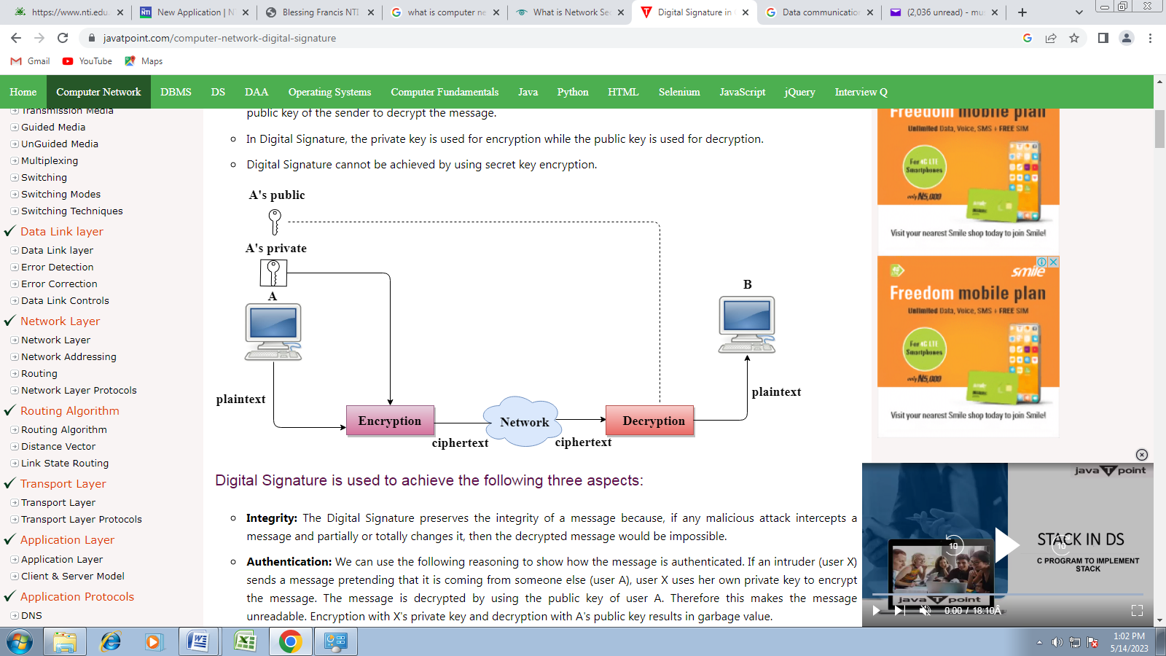

Digital Signature is used to achieve the following three aspects:
- Integrity: The Digital Signature preserves the integrity of a message because, if any malicious attack intercepts a message and partially or totally changes it, then the decrypted message would be impossible.
- Authentication: We can use the following reasoning to show how the message is authenticated. If an intruder (user X) sends a message pretending that it is coming from someone else (user A), user X uses her own private key to encrypt the message. The message is decrypted by using the public key of user A. Therefore this makes the message unreadable. Encryption with X's private key and decryption with A's public key results in garbage value.
- Non-Repudiation: Digital Signature also provides non-repudiation. If the sender denies sending the message, then her private key corresponding to her public key is tested on the plaintext. If the decrypted message is the same as the original message, then we know that the sender has sent the message.

Signing the Digest
- Public key encryption is efficient if the message is short. If the message is long, a public key encryption is inefficient to use. The solution to this problem is to let the sender sign a digest of the document instead of the whole document.
- The sender creates a miniature version (digest) of the document and then signs it, the receiver checks the signature of the miniature version.
- The hash function is used to create a digest of the message. The hash function creates a fixed-size digest from the variable-length message.
- The two most common hash functions used: MD5 (Message Digest 5) and SHA-1 (Secure Hash Algorithm 1). The first one produces 120-bit digest while the second one produces a 160-bit digest.
- A hash function must have two properties to ensure the success:
  - First, the digest must be one way, i.e., the digest can only be created from the message but not vice versa.
  - Second, hashing is a one-to-one function, i.e., two messages should not create the same digest.

Following are the steps taken to ensure security:
- The miniature version (digest) of the message is created by using a hash function.
- The digest is encrypted by using the sender's private key.
- After the digest is encrypted, then the encrypted digest is attached to the original message and sent to the receiver.
- The receiver receives the original message and encrypted digest and separates the two. The receiver implements the hash function on the original message to create the second digest, and it also decrypts the received digest by using the public key of the sender. If both the digests are same, then all the aspects of security are preserved.
At the Sender site
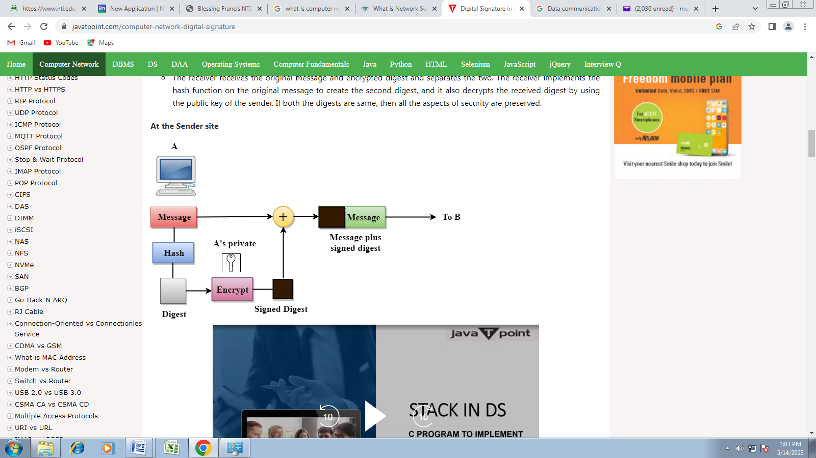
At the Receiver site
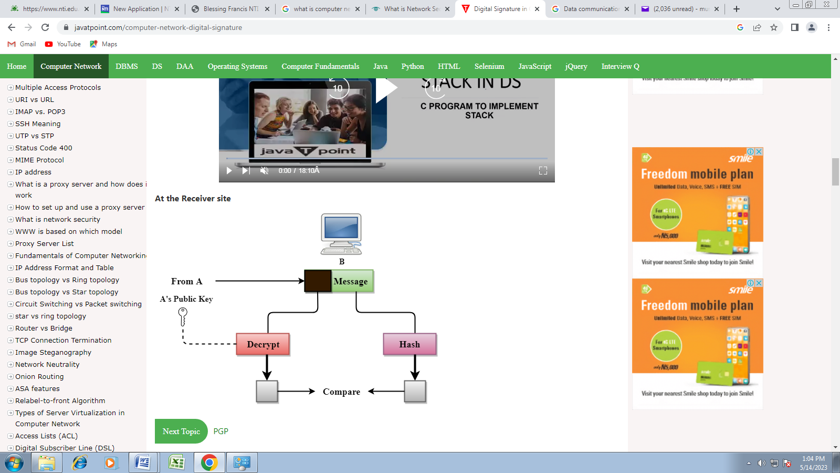
- Steganography
Steganography : is derived from two Greek words:'stegos,' which means 'to cover,' and 'grayfia,' which means 'writing,' thus translating to 'covered writing,' or 'hidden writing.' Steganography is a method of concealing sensitive information by embedding it in an audio, video, image, or text file. It is one of the techniques used to protect confidential or sensitive data from malicious attacks.

Types of steganography

There are five main types of steganography. These are:
- Text 2. Image 3.Video 4. Audio 5. Network steganography

Uses of steganography

In recent times, steganography has been mainly used on computers with digital data being the carriers and networks being the high-speed delivery channels. Steganography uses include:
- Avoiding censorship: Using it to send news information without it being censored and without fear of the messages being traced back to their sender.
- Digital watermarking: Using it to create invisible watermarks that do not distort the image, while being able to track if it has been used without authorization.
- Securing information: Used by law enforcement and government agencies to send highly sensitive information to other parties without attracting suspicion.

Steganography vs. cryptography
S/N | Factors | Steganography | Cryptography
1 | Explanation | It's a method to conceal the fact that communication is taking place | It's a method for making information unintelligible
2 | Aim | Maintain communication security | Enable data protection
3 | Key | Optional, but increases security when utilized | Necessary prerequisite
4 | Data Visibility | No | Yes
5 | Failure | Once hidden information is decoded, the data can be used by anyone | You can recover the original message from the ciphertext if you can access the decryption key
6 | Data Structure | Does not modify the data's general structure | Modifies the overall data structure

Cloud Computing

What is Cloud Computing
Cloud Computing is essentially the on-demand supply of computer system resources like data storage and computing power over the Internet. A core concept in Cloud Computing is that the location of the service and other factors, like the hardware or operating system on which it is running, are not relevant to the user. Although over-simplified, this is how the concept of cloud as a metaphor was borrowed from old telecoms network schematics.

Characteristics of Cloud Computing
Cloud Computing models possess five essential characteristics:
- Broad network access
- Resource pooling
- On-demand self-service
- Rapid elasticity
- Measured service
Benefits of Cloud Computing
- Wide applications
- Reduced upfront licensing cost
- Lower cost of hardware
- Allows working from any computer anywhere
- Saves money
- Drives sales

Cloud Computing Architecture
Cloud Computing architecture is a blend of event-driven and service-oriented architectures. It is divided into the front end and the back end:
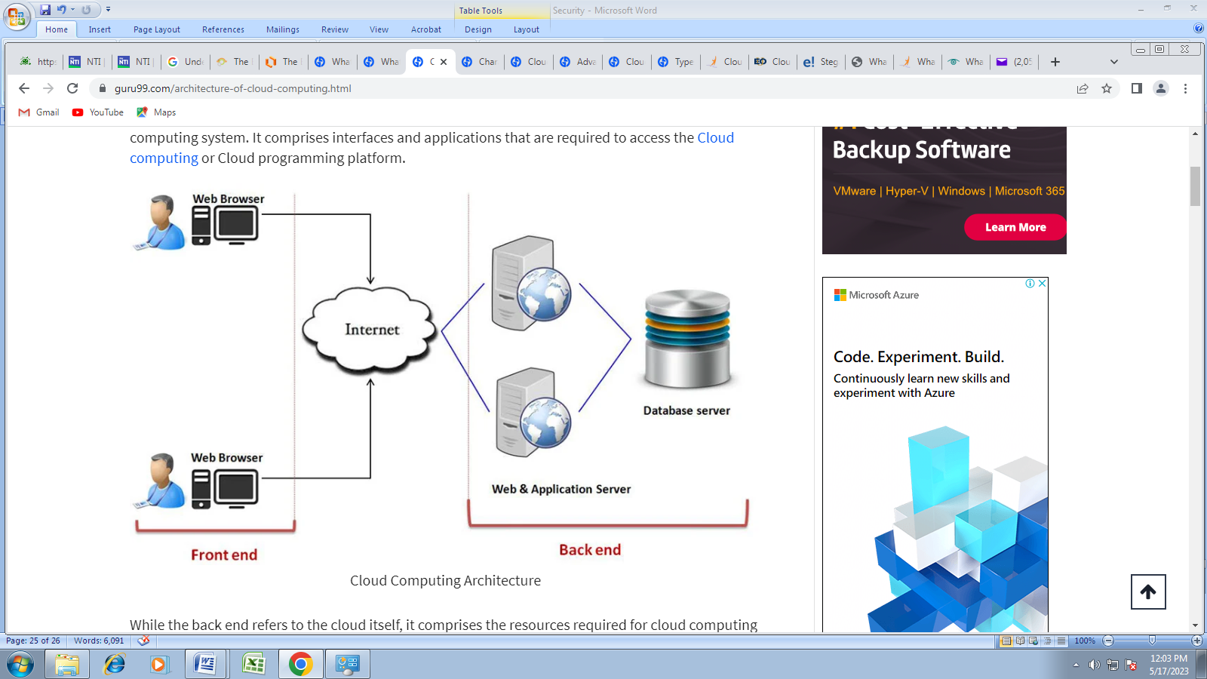
- Front End: The front end contains the client-side interfaces and applications for accessing Cloud Computing platforms. It is used by the client and includes web servers, mobile devices, thin and fat clients, and tablets.
- Back End: The back end is used by service providers, and it oversees the management of the required resources for providing Cloud Computing services. It constitutes a huge amount of data storage, virtual machines, security mechanism, deploying models, traffic control mechanisms, servers, etc.
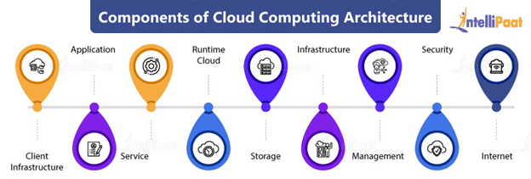

Components of Cloud Computing Architecture
1. Client infrastructure: A front-end component that provides GUI for interaction with the cloud
2. Application: Any platform or software that a client wants to access
3. Service: Manages the type of service (SaaS, PaaS, or IaaS) accessed according to the requirement of the client
4. Runtime cloud: Provides the runtime and execution environments to virtual machines
5. Storage: An important component that provides a large storage capacity in the cloud for the storage and management of data
6. Infrastructure: Provides services on the application level, host level, and network-level and includes software and hardware components such as storage, network devices, servers, virtualization software, and other storage resources required for supporting the Cloud Computing model
7. Management: Manages components such as application, storage, infrastructure, runtime cloud, service, and other security issues in the backend and helps maintain coordination between them
8. Security: A built-in back-end component that employs a security mechanism
9. Internet: A medium that enables front-end and the back-end interaction.
Types of Clouds

1. Public Cloud: The public cloud is open to all for the storage and access of data over the Internet. It utilizes the pay-per-usage method, and the computing resources are managed and run by the cloud service provider (CSP). Example: EC2, Google App Engine, IBM SmartCloud Enterprise, Windows Azure Services Platform, etc.

2. Private Cloud: The private cloud (internal cloud/corporate cloud) is used by organizations for the development and management of data centers internally or by a third party. It is deployed using open-source tools such as Eucalyptus and OpenStack.

3. Hybrid Cloud: The combination of the public and the private cloud models is called a hybrid cloud.
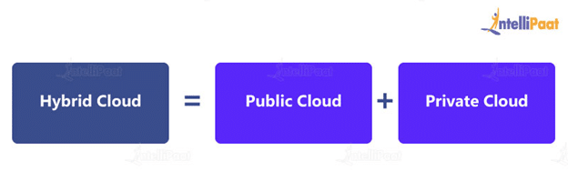This configuration makes the hybrid cloud partially secure. The services on the public cloud can be accessed by anyone, and the ones running on the private cloud can be accessed solely by the organization’s users. Example: Gmail, Google Drive, Google Apps, AWS, MS Office on the Web, One Drive, etc
Community Cloud
The community cloud, as the name suggests, allows services and systems to be accessible by a group of organizations to share information between them and a specific community. It can be owned, operated, and managed by multiple organizations in the community, a third party, or a combination of them. Example: The US-based dedicated IBM SoftLayer cloud for federal agencies, healthcare community cloud, etc.
Cloud Computing Services (Cloud service models)
Cloud solutions come in three primary service models: Infrastructure as a Service (IaaS), Platform as a Service (PaaS), and Software as a Service (SaaS).

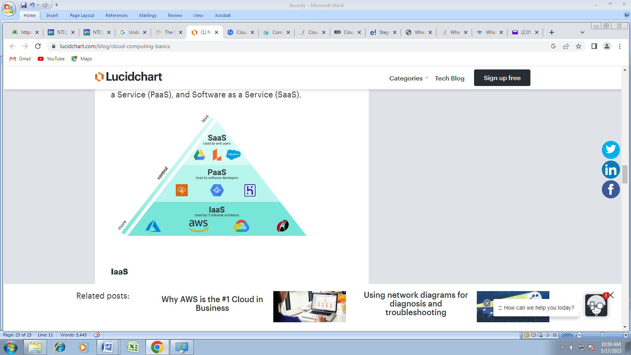

Software as a Service (SaaS): SaaS (also known as cloud application services) mostly runs directly through the web browser without downloading and installing these applications. Example: Dropbox, Google Apps, Slack, Hubspot, Salesforce, Cisco WebEx, etc.

Platform as a Service (PaaS): PaaS (also known as cloud platform services) is similar to SaaS, but it provides a platform for software creation. Example: Windows Azure, Magento Commerce Cloud, Force.com, OpenShift, etc.

Infrastructure as a Service (IaaS): IaaS (also known as cloud infrastructure services) manages applications’ data, runtime environments, and middleware. Example: Google Compute Engine (GCE), AWS EC2, Cisco Metapod, etc.

Applications of Cloud Computing
Cloud Computing technology is most widely used in the following areas:
- Art applications: Cloud Computing offers various art applications such as Adobe Creative Cloud, Vistaprint, Moo, etc.
- Business applications: Business applications such as Mailchimp, Salesforce. PayPal, etc. are based on cloud service providers.
- Data storage and backup applications: Cloud Computing allows storage of data on the cloud and access over the Internet along with backup recovery applications. Examples: Google G Suite, Mozy, Box.com, etc.
- Education applications: Cloud Computing in the education sector offers virtual classroom environments, online learning platforms, and student learning portals, which can be accessed by students. Examples: Google Apps for Education, Chromebooks, tablets with Google Play for Education, AWS in education, etc.
- Entertainment applications: Entertainment industries employ a multi-cloud strategy for audience interaction. Examples: Online games, video conferencing apps, etc.
- Management applications: Cloud management tools help in the management of all types of cloud activities, such as data integration, resource deployment, and disaster recovery, and provide administrative control over the applications, platforms, and infrastructure. Examples: Evernote, GoToMeeting, Toggle, etc.
- Social applications: Social cloud applications allow a large community of users to connect with each other via social networking applications such as Facebook, Twitter, LinkedIn, etc.

Virtualization and Cloud Computing
The main enabling technology for Cloud Computing is Virtualization. Virtualization is the partitioning of a single physical server into multiple logical servers. Once the physical server is divided, each logical server behaves like a physical server and can run an operating system and applications independently. Many popular companies like VMware and Microsoft provide virtualization services. Instead of using your PC for storage and computation, you can use their virtual servers. They are fast, cost-effective, and less time-consuming. For software developers and testers, virtualization comes in very handy. It allows developers to write code that runs in many different environments for testing.
Virtualization is mainly used for three main purposes: 1) Network Virtualization, 2) Server Virtualization, and 3) Storage Virtualization
Network Virtualization: It is a method of combining the available resources in a network by splitting up the available bandwidth into channels. Each channel is independent of others and can be assigned to a specific server or device in real time.
Storage Virtualization: It is the pooling of physical storage from multiple network storage devices into what appears to be a single storage device that is managed from a central console. Storage virtualization is commonly used in storage area networks (SANs).
Server Virtualization: Server virtualization is the masking of server resources like processors, RAM, operating system, etc., from server users. Server virtualization intends to increase resource sharing and reduce the burden and complexity of computation from users.
Virtualization is the key to unlock the Cloud system, what makes virtualization so important for the cloud is that it decouples the software from the hardware. For example, PCs can use virtual memory to borrow extra memory from the hard disk. Usually, a hard disk has a lot more space than memory. Although virtual disks are slower than real memory, if managed properly, the substitution works perfectly. Likewise, there is software that can imitate an entire computer, which means 1 computer can perform the functions equals to 20 computers.

